Outreach 120-Day Detail Opportunity

GS-401-11 Supervisory Natural Resource Specialist Position

Recreation Program Manager
Gold Beach and Powers Ranger Districts
Rogue River - Siskiyou National Forest

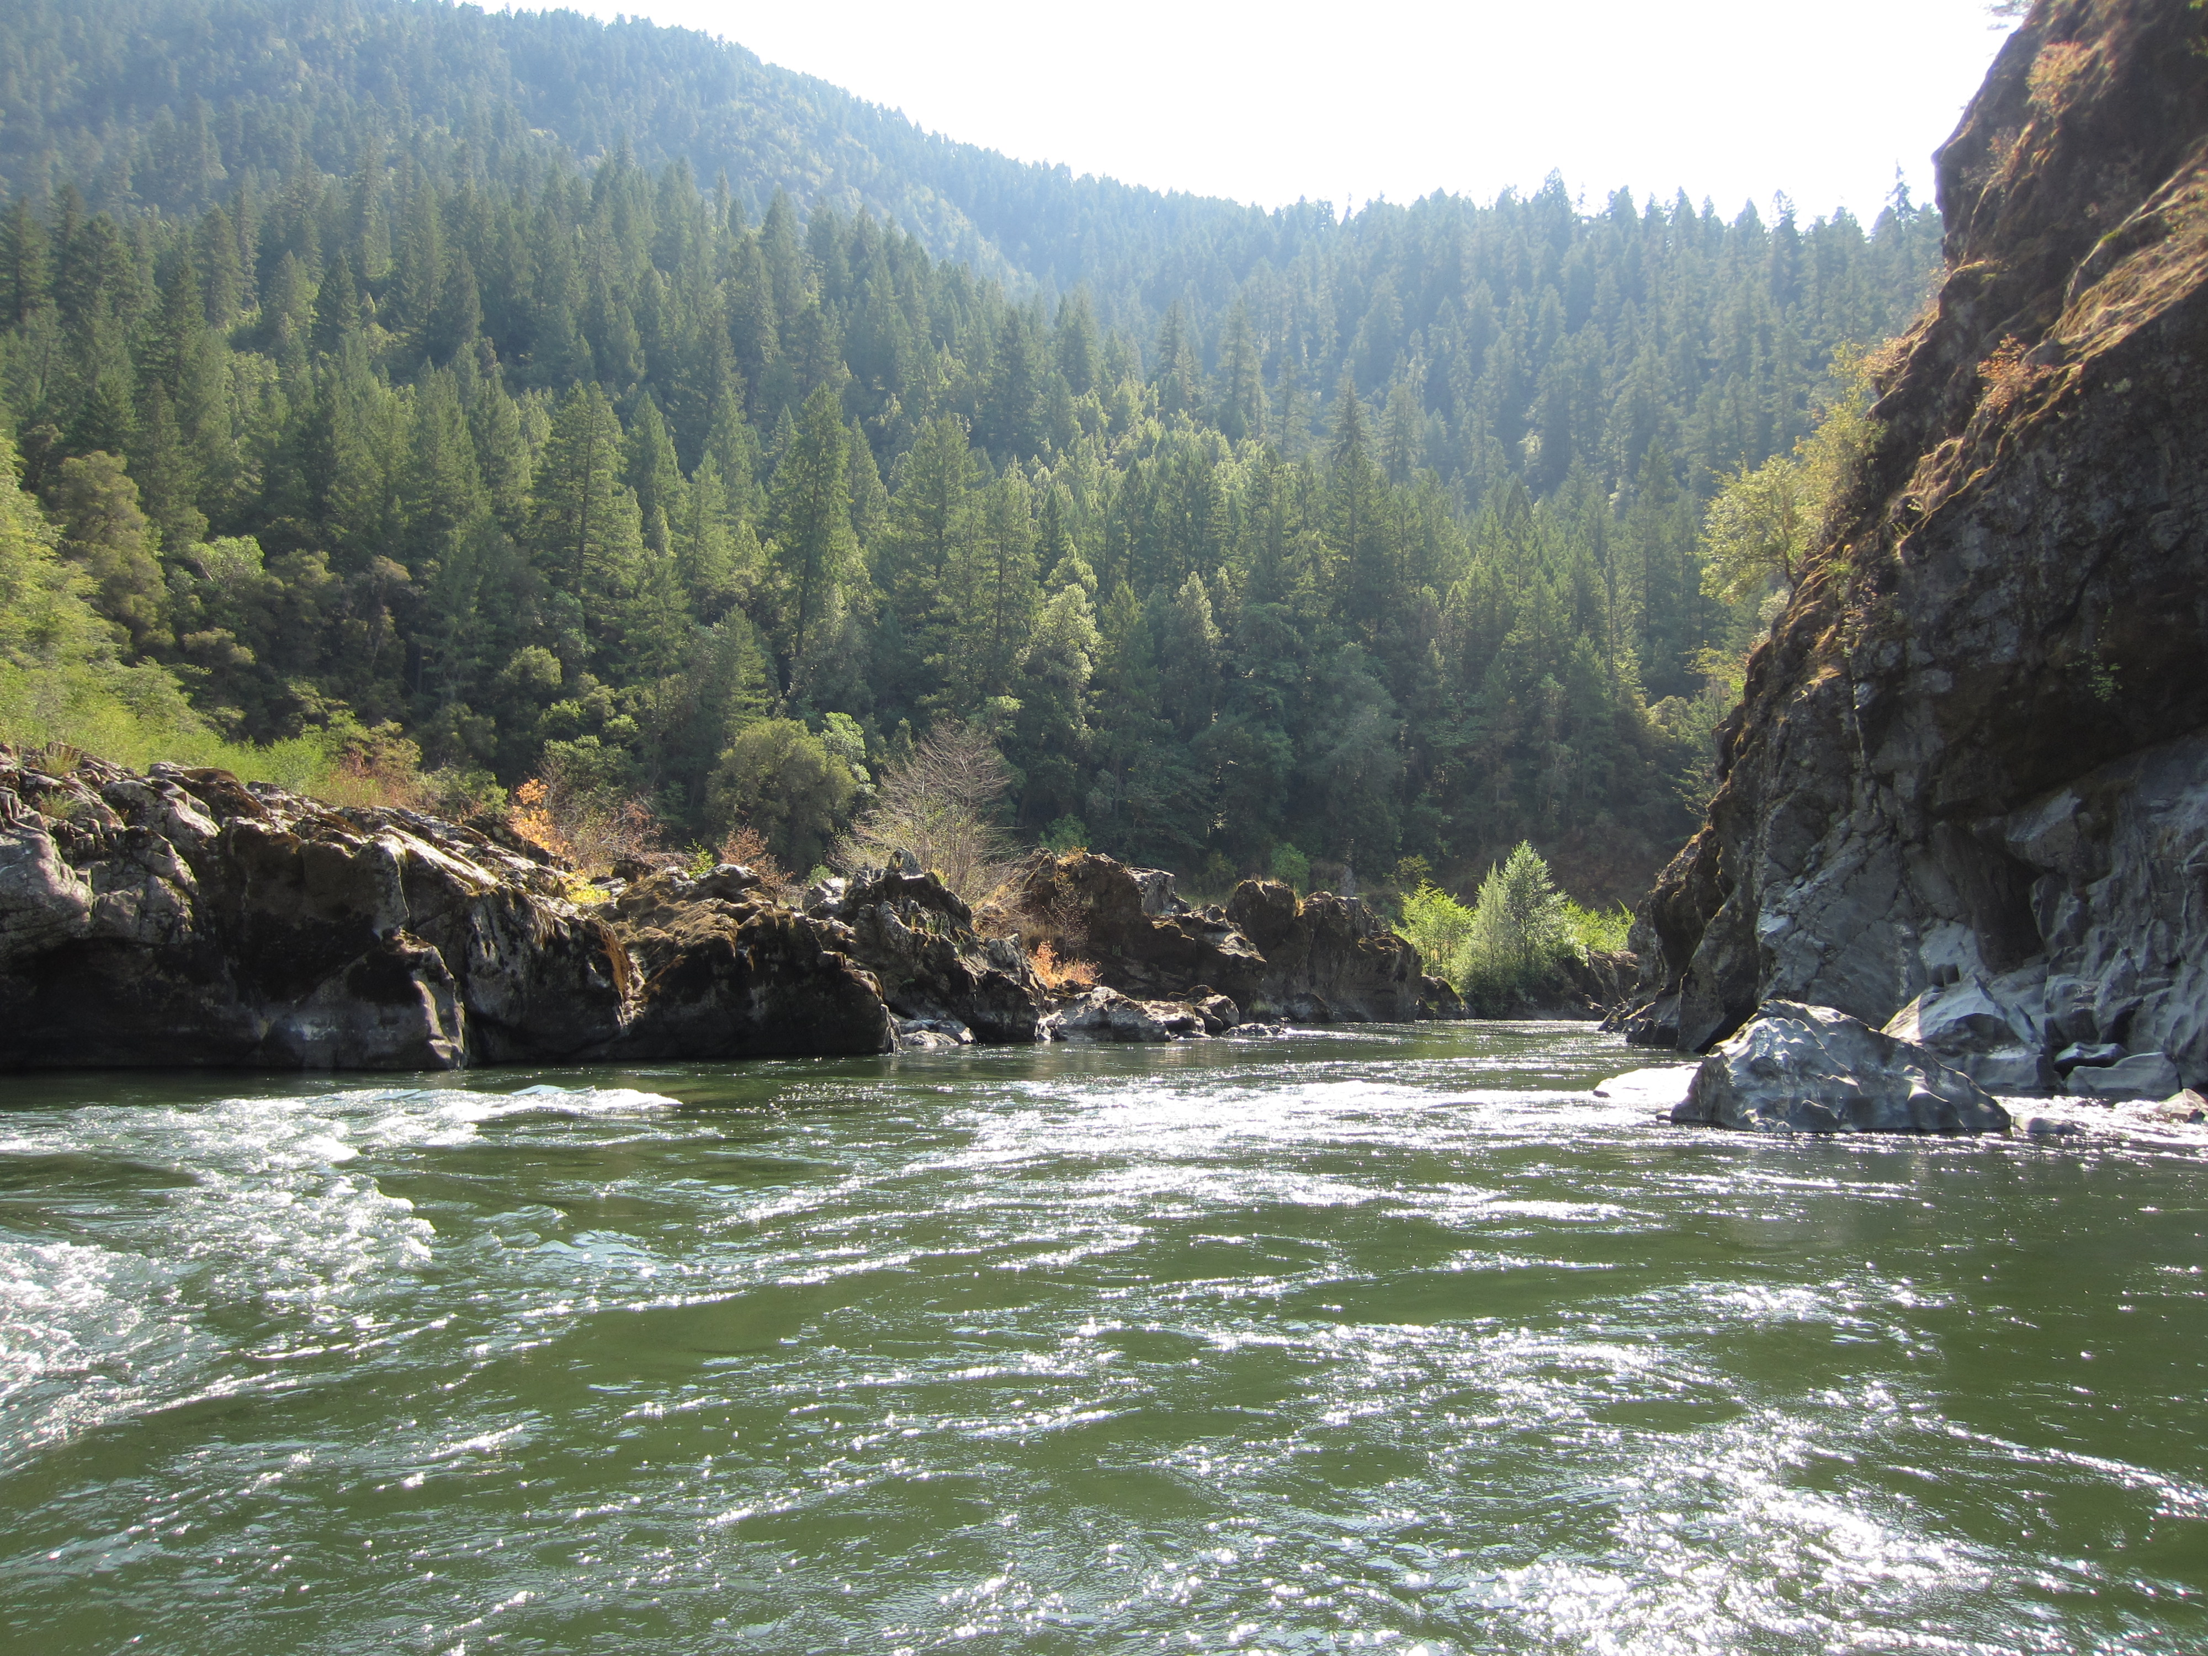

The Gold Beach and Powers Ranger Districts of the Rogue River-Siskiyou National Forest is looking for a 120-day detailer to fill a GS-0401-11 Recreation Program Manager with a 20% partnership component position. The duty station is Gold Beach, OR. The purpose of this outreach notice is to fill a 120-day detail, inform prospective applicants of this opportunity and help us determine the area of consideration for a future permanent fill. If you are interested, please send a completed outreach response form and resume to David Sheehan (dsheehan@fs.fed.us) by November 21, 2018. For additional information about the position, please contact Wade McMaster (Acting District Ranger) at (541) 247-3601 or wmcmaster@fs.fed.us or David Sheehan (Recreation Program Manager) at (541) 247-3640 or dsheehan@fs.fed.us.

Gold Beach and Powers Ranger Districts
Located in southwestern Oregon, the Gold Beach and Powers Ranger Districts offer amazing, year-round recreation, including five wild and scenic rivers, over 200 miles of hiking trails, four federally-designated wilderness areas, and a range of camping opportunities from the highly-developed campgrounds along the lower section of the Rogue River to dispersed campsites deep in the Kalmiopsis Wilderness. The temperate coastal climate, along with winter steelhead and chinook salmon runs on the Chetco and Rogue Rivers, invite year-round use. We also have large and complex recreation special uses and scenic conservation easement programs. We’re looking for a candidate with the passion and skills to reach out to partners and engage local communities in collaborative public land stewardship.

Position Duties
This position provides zoned program leadership for the developed recreation, recreation special uses, wild and scenic rivers, wilderness, trails, and scenic conservation easement programs. Primary duties are as follows:
- Serve as a principle staff member and Acting District Ranger in a staff rotation.
- Supervise three permanent employees and three seasonal employees. Establish and communicate guidelines and performance requirements to employees; conduct formal performance reviews; and identify developmental and training needs of employees. Ensure district safety protocols are followed by employees, partners, and volunteers.
- Maintain partnerships and existing agreements with the Bureau of Land Management, State agencies, local government, interest groups, and stakeholders. Attend meetings with established partnership groups to maintain relationships and provide Forest Service representation. Establish new partnerships and build volunteer capacity to improve trail maintenance, wilderness stewardship, wild and scenic river management, and developed recreation programs. Secure grant and federal funding opportunities to support these programs.
- Initiate internal Title 2 RAC proposal(s) that support the Forest Recreation Program in Coos and Curry Counties.
- Assist external applicants/partners with the development of appropriate, NEPA-ready Title 2 RAC proposals in support of the Siskiyou Resource Advisory Committee meeting. Initiate development and finalization of agreements for external or internal projects approved. Serve as key interdisciplinary team member on large-scale landscape restoration projects. Complete recreation and visual environmental analyses for proposed recreation and land use and development projects. Provide reports to fulfill NEPA requirements for analysis of West Zone projects.
- Oversee the recreation program budget. Project program costs based on staffing, contract, equipment, and supply needs. Prepare out-year work plans and provide oversight for purchasing and acquisition.
- Ensure annual accomplishment reporting is completed and recommends adjustments based on regional and forest-level direction, district priorities, budget allocations, and resource capabilities.

Gold Beach Area Information
Located on the Wild Rivers Coast of southern Oregon, Gold Beach (pop. 2,300) is situated in Curry County (pop. 22,000) at the mouth of the Rogue River. The Rogue River provides some of the best salmon fishing and whitewater rafting opportunities in the Pacific Northwest. Other popular recreational activities include beach combing, biking, hiking, surfing, kite boarding, and windsurfing. The climate is generally mild, with summertime temperatures in the mid-60s. Winters are cool and wet, and snow is common in the mountains. Average annual rainfall is 80 inches. More information about the Gold Beach area may be found at http://goldbeach.org/ or http://oregon.hometownlocator.com/or/curry/gold-beach.cfm.

OUTREACH RESPONSE FORM

GS-401-11 Supervisory Natural Resource Specialist Position

Recreation Program Manager
Gold Beach and Powers Ranger Districts
Rogue River - Siskiyou National Forest

If you are interested in this detail, please complete this form and email it with your resume to dsheehan@fs.fed.us by November 21, 2018. If you do not have access to electronic mail, please complete the form and mail or fax that and your resume to: David Sheehan, Gold Beach Ranger District, 29279 Ellensburg Ave., Gold Beach, OR or (541) 247-3617 (fax).
Name |  | Date
Address
City |  | State
Zip |  | E-Mail
Phone number(s):
Are you currently a federal employee? ___YES ___NO
If yes, current agency and location:
Current title/series/grade:
Type of appointment: ___ Permanent ___ Term ___ Temporary
If you are not a current permanent (career or career conditional) employee, are you eligible for appointment under any of the following special authorities (check the appropriate box):
 | Person with Disabilities
 | Veteran Recruitment ACT
 | Former Peace Corps Volunteer
 | Disabled Veteran with 30% Compensable Disability
 | Pathways Student Program
 | Veterans Employment Opportunities Act 0f 1998
 | Other, please describe:

Briefly describe why you will be a quality candidate for this position. Attach additional pages if needed.

