National Wild & Scenic Rivers Program
National Park Service
U.S. Department of the Interior
Partnership Rivers Newsletter, Issue 4
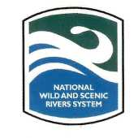 Partnership Rivers News
  - Summer 2010
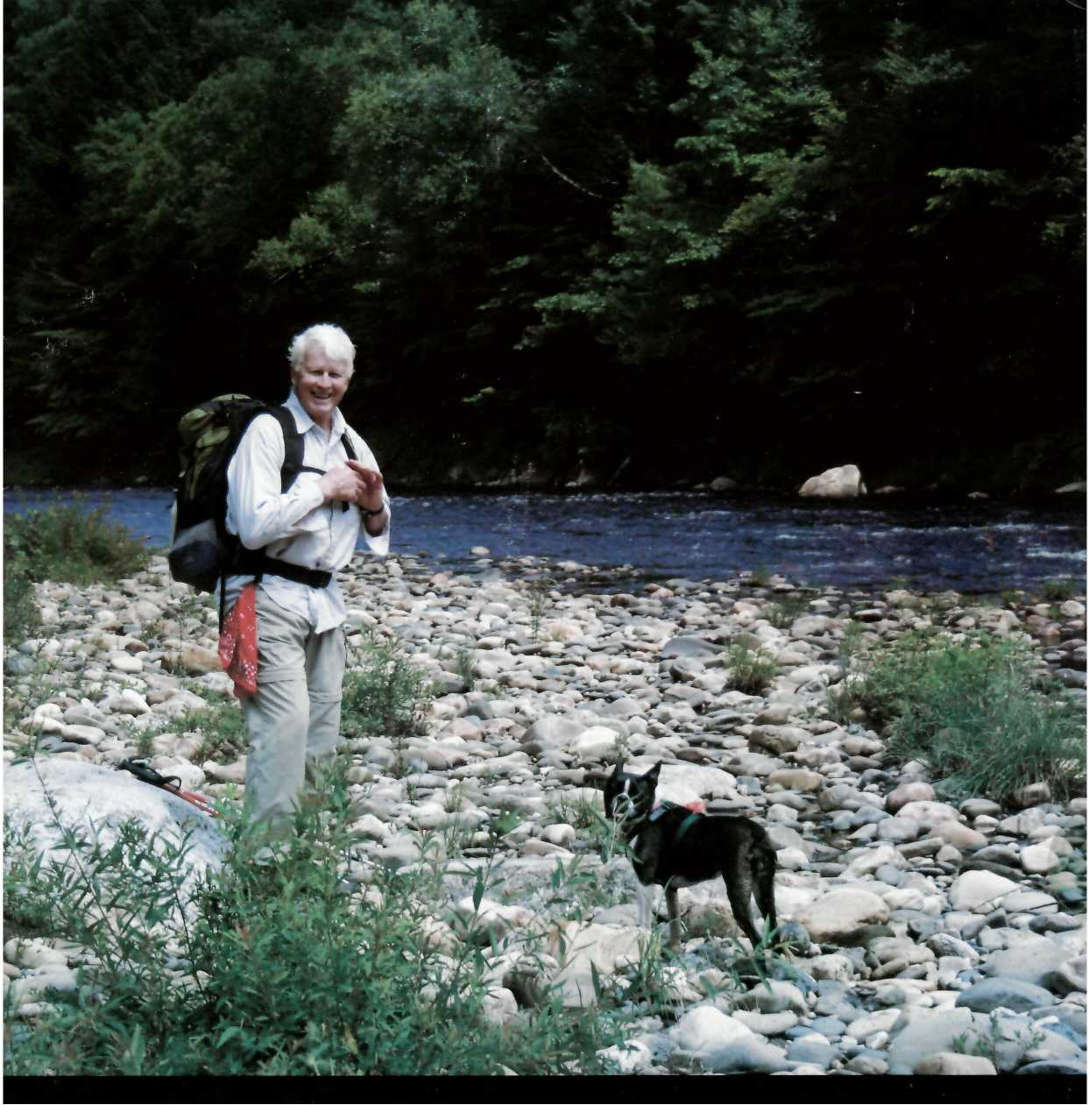
1 "Man and Best Friend on the Westfield," photo by Meredyth Babcock
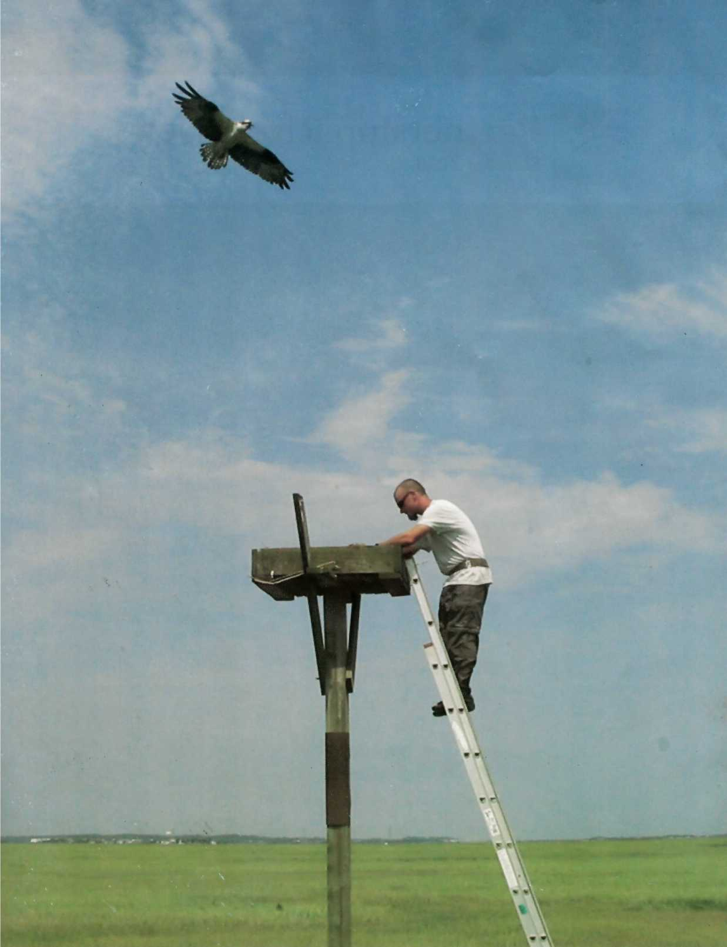
2 A volunteer installs one of 15 new Osprey nest platforms in the Wild & Scenic Great Egg Harbor Estuary, requested by the New Jersey Endangered and Non-game Species Program.

Contents

National Wild & Scenic Rivers 06
Program Mission Statement 06
What is a Partnership Wild & Scenic River? 06

Highlighted Rivers of 2010 06
Wild & Scenic Rivers Map 07
Lower Farmington River 06
By Joyce Kennedy
Missisquoi and Trout Rivers 07
By Jamie Fosburgh
Eightmile and Taunton Rivers 08
By Jamie Fosburgh

Local Partner Organizations:

The Lifeblood of Sustainable

River Protection 10
By Fred Akers

Rivers Depend on Volunteers 14
By Rachel Carpman

Invasive Species:

A Growing Threat 18
By Lee Steppacher

White Clay Creek Watershed 21
By Julie Bell

Contact Information 24
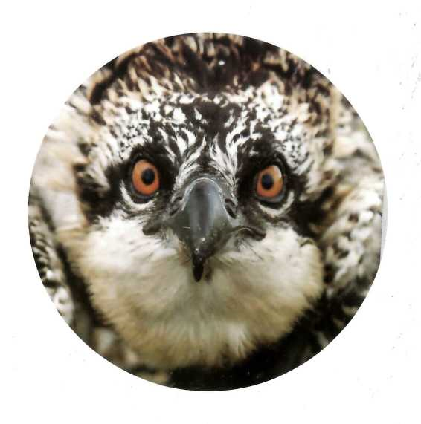
3 With the helping hands of state biologists and concerned citizens, the Osprey are staging a strong come-back from the chemical pollution and habitat losses of the past to build their nesting population up from a record low of 68 pairs statewide in 1975.
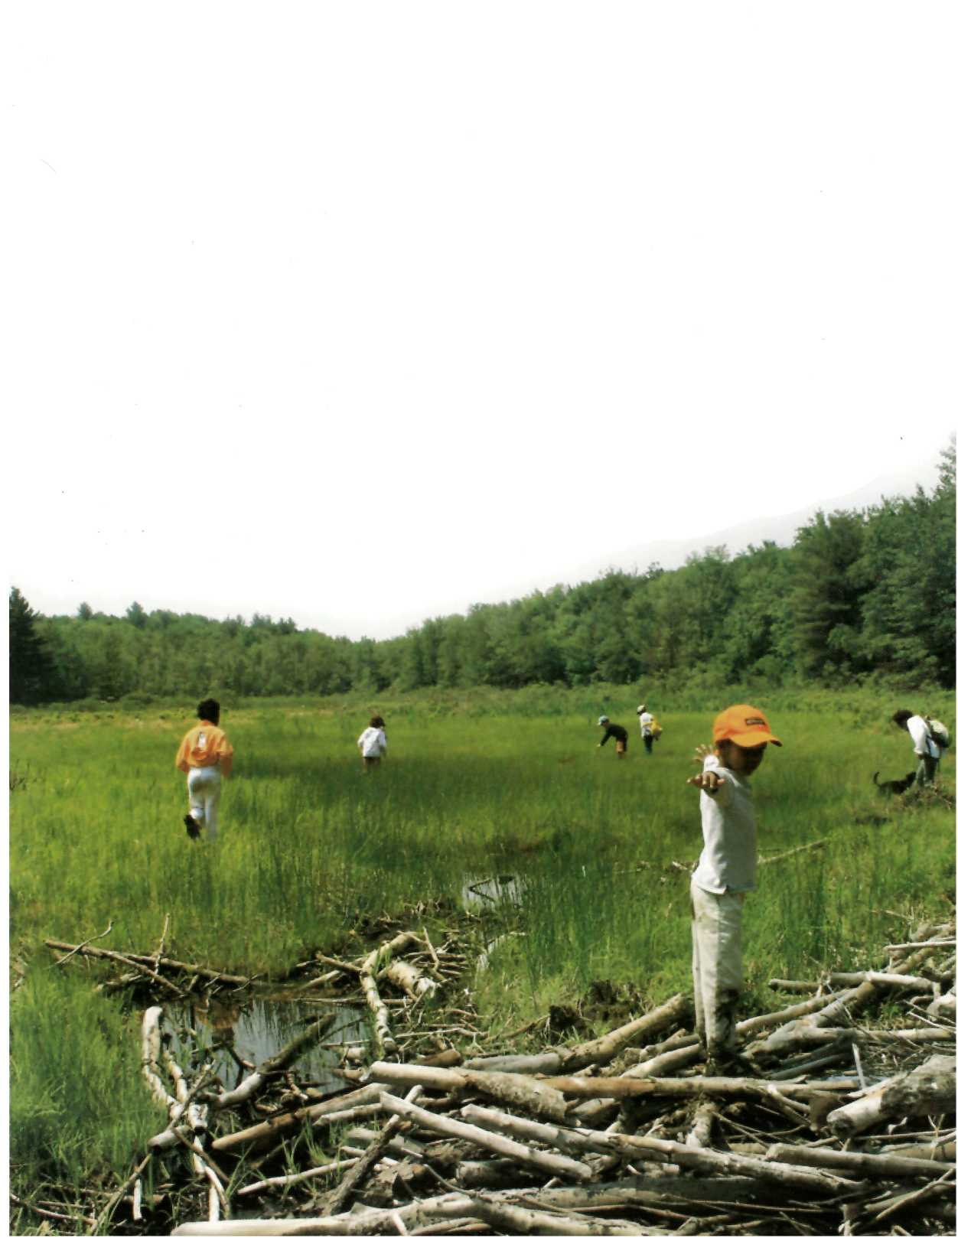
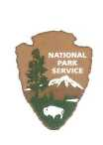 National Park Service – U.S. Department of the Interior
200 Chestnut Street
Philadelphia, Pennsylvania 19106
Partnership Rivers News is published by the Northeast Region of the National Park Service.
Division Chief • Northeast Region Rivers Program
Chuck Barscz
Charles_Barscz@nps.gov
215.597.6482
New England Team Leader
Jamie Fosburgh
Jamie_Fosburgh@nps.gov
617.223.5191
Partnership Rivers ● National Program Lead
Charlie Stockman
Charlie_Stockman@nps.gov
202.354.6907
Designer
Cassandra J. Huck

Our Mission Statement
The Partnership Wild & Scenic Rivers Program is dedicated to protecting nationally significant river resources through locally based partnerships.

What is a Partnership Wild & Scenic River?
The national Wild & Scenic River Program, created in 1968, includes over 200 rivers and river segments throughout the country. While the vast majority of these rivers are in the west and flow through federal land—National Forests, National Parks etc.—a small subset of Partnership Rivers have been designated since 1992, based on the local partnership model.
Starting in 1992, a new category of Wild & Scenic Rivers began in the Northeast Region that would become known as Partnership Wild & Scenic Rivers (sometimes known as PWSR). Unlike the more traditional federally owned and managed Wild & Scenic Rivers, local river protection advocates motivate Congress to study and designate these “private land” rivers that will then be protected and managed locally in partnership with Congress and the National Park Service.
Partnership Rivers flow through a patchwork of private and public lands. Many flow through local communities and are the centerpiece of community life, both past and present. The National Park Service now recognizes 14 Partnership Rivers and Study Rivers. While the National Park Service maintains administrative responsibilities for the rivers, they are managed in partnership with local communities and organizations. Each river has a local committee, created by legislation, to work with and advise NPS on protection of the outstanding resources of the river.
This model has been very successful, as you will see in the pages that follow. In 2007, the Ash Institute for Democratic Governance and Innovation named the Partnership Wild & Scenic model one of the top 50 government innovations linking citizens with important public services.

New Additions to Partnership Rivers Program
Introducing two new congressionally authorized Wild & Scenic studies and welcome two newly designated rivers.

Lower Farmington River and Salmon Brook Study River (CT)
The success of the upper Farmington River’s 1994 Wild & Scenic River designation is proving contagious. To the thinking of the Farmington River Watershed Association (FRWA) and longtime congressional sponsors, consideration of expanding Wild and Scenic status to the “Valley” segment of the Lower Farmington, as well as its outstanding tributary, Salmon Brook, amounted to a “no-brainer.” And it turned out the communities agreed; a study bill was horn in 2005 and passed in 2006 with overwhelming community support from the 10 adjacent communities.
A locally appointed Wild & Scenic Study Committee began meeting in April, 2007, based around committee members appointed by their towns. They have brought a wealth of knowledge and experience in governmental, ecological and organizational processes to the study effort. The committee’s credentials, the expertise of independent researchers, local supporting agencies and professional contractors, and input from the general public have helped ensure the study’s progress.
Since the Committee first began meeting, its work has confirmed the view of the FRWA and many Farmington Valley residents that the unique natural and cultural resources of the lower Farmington and Salmon Brook make the study area eligible for a Wild & Scenic designation. The Study Committee believes that a Wild & Scenic designation will highlight the Outstanding Resource Values of the watercourses, will provide a sense of connectedness and pride to the people of the Farmington River Valley and will enhance economic opportunities. Also, the Study Committee wants the river towns to benefit from the availability of National Park Service funding and technical resources to augment their efforts to protect the natural and cultural resources of the lower Farmington and Salmon Brook.
The lower Farmington River & Salmon Brook Management Plan is being developed by the Wild & Scenic Study Committee.
The Study Committee is in the process of seeking input and endorsements for the designation from town land use commissions, local citizens, the state and other key stakeholders and intends to have a Study Report ready in 2010.

Missisquoi and Trout Rivers Study Rivers (VT)
Authorized as a part of March 2009’s omnibus parks legislation, the Wild & Scenic River Study for the Trout and upper Missisquoi Rivers formally commenced in September with the inaugural meeting of the locally- based Study Committee. Local initiative to seek the study was spearheaded by the Missisquoi River Basin Association, which explored the potential study for more than two years in conjunction with the 10 local communities.
The study is significant as Vermont’s first ever congressionally authorized Wild & Scenic River Study - a breakthrough which would not likely have happened without the strong track record of the Partnership Wild & Scenic River model upon which the Study is being based.
Consistent with the Partnership Rivers approach, the heart of the study will be the locally- based Study Committee with core representation appointed the boards of selectmen of the ten abutting communities. Additional members of the Committee include representatives from: VT Department of Environmental Conservation; VT Agency of Agriculture; Northwest Regional Planning Commission; VT Traditions Coalition; VT Federation of Sportsman’s Clubs.
A local study coordinator has recently been hired by the Missisquoi River Basin Association though a cooperative agreement with the National Park Service. The coordinator will be locally-based, and will coordinate the study in association with the Study Committee.
This formula will ensure that the Study as a whole is conducted with maximum participation and buy-in at the local community level—a foundation principal of the Partnership Rivers model.

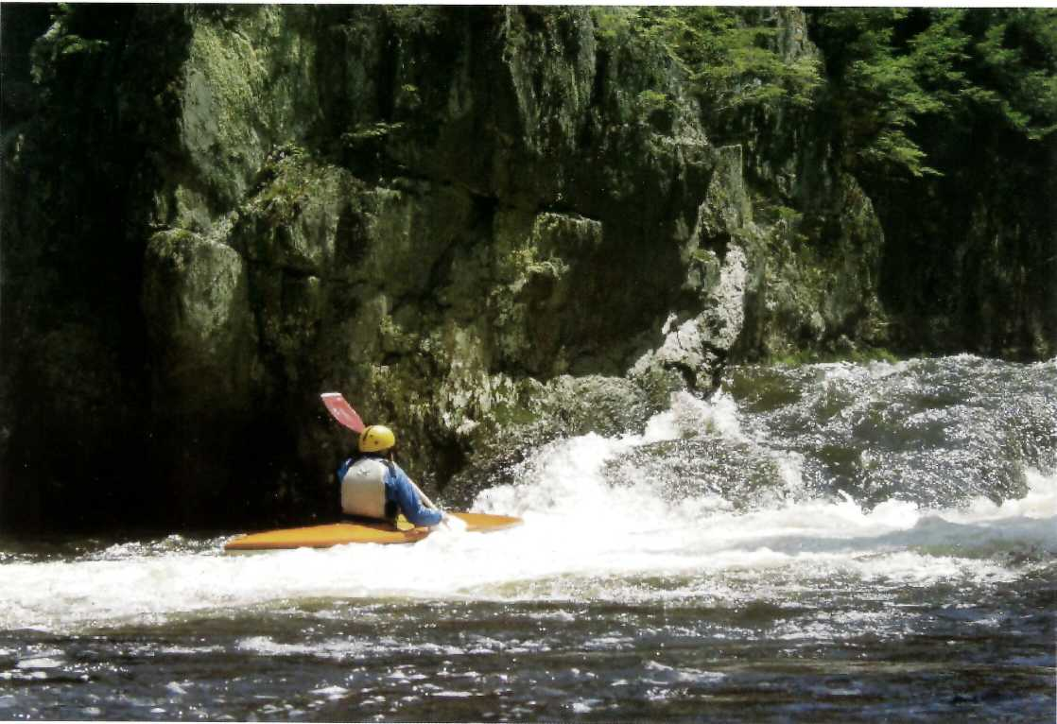
4 A whitewater kayaker enjoys playing in a wave on northern Vermont's Missisquoi Wild & Scenic study river.

New Designations: Eightmile and Taunton Wild & Scenic Rivers
The Eightmile River in Connecticut (2008) and the Taunton River in Massachusetts (2009) become the nth and 12th rivers to join the National Wild & Scenic Rivers System following the Partnership designation model. At 40 miles, the Taunton is unique as Massachusetts’s longest undammed mainstem river, and supports the state’s largest anadromous fish runs—one of many special values recognized through the designation.
The Eightmile is the second Partnership River to follow a watershed-based designation approach (joining White Clay Creek). It is recognized as one of Connecticut’s most intact and pristine watersheds, with no permitted discharges and outstanding water quality. In 2009, the aptly named Eightmile Wild & Scenic River Watershed was able to utilize funding received through the National Park Service to hire a local coordinator to oversee the designation and work with local partners to implement the Watershed Management Plan.
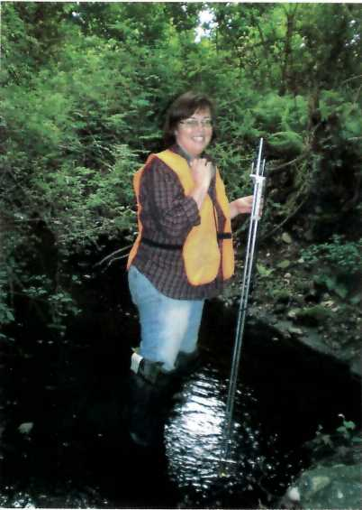
5 "Long term river protection starts at the top of the watershed and includes everybody and everything it encounters along the way."

Hydro Power on Wild & Scenic Rivers?
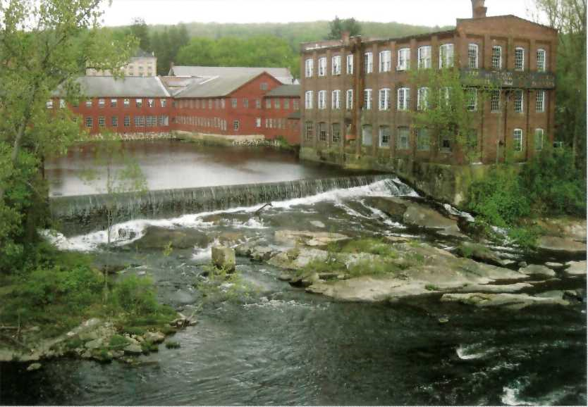
6 The historic Collinsville project on the Lower Farmington River provides a case in point: An existing, highly historic dam that is not a candidate for removal; FERC licensing would require development of a fish passage, a longtime goal of state and federal fisheries agencies; The dam would operate in a run-of-the-river mode with adequate by-pass flows to protect resource values including aesthetics and fisheries.

The push towards “green” energy projects, high fuel oil costs, the availability of tax credits and even the renewal of old and seemingly forgotten projects have all contributed to the increase in proposals to construct or re-activate hydro-electric projects that are regulated by the Federal Energy Regulatory Commission (FERC).
In the past couple of years, projects on or potentially affecting designated Wild & Scenic Rivers or Congressionally authorized study rivers have been popping up on rivers throughout the Northeast Region, following decades with little or no interest. Examples can be found on the Westfield, Concord, Sudbury & Assabet, Farmington, Missisquoi Rivers, and likely others as well.
While new projects cannot be licensed by FERC directly on a designated river segment, projects may proceed upstream, downstream or on tributaries. In the case of study rivers, such as the Missisquoi and Lower Farmington Rivers, it is also possible to exclude stretches of river from any eventual designation proposal specifically to allow for future projects to be brought online. In fact, the study process provides an excellent opportunity to review potential hydro sites in conjunction with local communities, state agencies, and other stakeholders and potentially reach consensus on such “exclusions” to allow for “green” hydro projects
that might coexist successfully with Wild and Scenic designations.
Not all projects, of course, will pass the “green” test, and the Wild & Scenic River protections as applied through the FERC preliminary permit and licensing process provide strong assurance that adverse projects will not proceed.
The key to providing timely and relevant input is to be plugged into the FERC process. The simple way to do so is to sign onto the service list for each project. This is done through FERC’S website, WWW.FERC.gov, where any member of the public can search their database by project name, applicant or river to find a project, and follow the directions to join the service list. Once on the service list, all filings by the applicant, comments by stakeholders and notices issued by FERC will be received electronically.

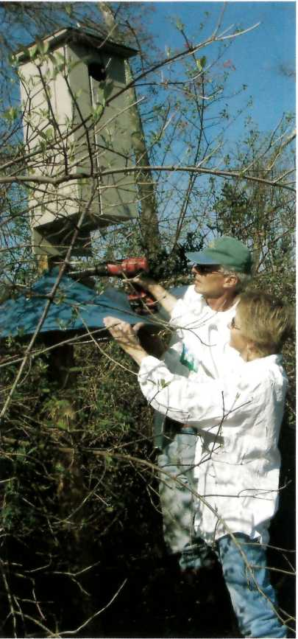

Local Partner Organizations—

The Lifeblood of Sustainable River Protection
The key to the success of Partnership Rivers is the long term advocacy, management leadership, and asset leveraging provided by the local nongovernmental partners. It is the local non-governmental partner—the watershed group, the land trust, the environmental education center—that has the best and most extensive outreach programs.

Since 1992, local and state river protection advocates in 7 states have motivated Congress to study, designate, and fund special Partnership Rivers. That’s eleven new Wild & Scenic Rivers on the East Coast covering over 700 river miles in 17 years, with 2 more special free- flowing rivers currently under study for designation as additional new Partnership Rivers. And the Partnership Rivers protections are working well.
The key to the success of Partnership Rivers is the long term advocacy, management leadership, and asset leveraging provided by the local nongovernmental partners, which is facilitated and supported by NPS management and long term Congressional appropriations. For example, it is the local nongovernmental partner—the watershed group, the land trust, the environmental education center—that has the best and most extensive outreach programs. Such a local partner may produce educational materials, work with the press on coverage of river-related events, host outings to bring community members to the rivers. They may organize topical forums, perform studies or gather volunteers to support monitoring activities. Working with support from the National Park Service and leveraging funds, the ngo’s are most effective in furthering protection goals for these special rivers. Today, not only do the Partnership Rivers nongovernmental organizations work within their own watershed, they have joined together, across 7 states, to collaborate at the national level with Congress and the National Park Service to keep Partnership Rivers protected and to encourage new rivers to become Partnership Rivers.
In an April 2007 recommendations report to the National Leadership Council, the National Park Service Wild & Scenic Rivers Task Force reported that Partnership Rivers received the highest grades of all Wild & Scenic
Rivers categories for meeting legislative/legal mandates, external coordination, policy guidance and staff training, and resource protection. Also in 2007, the Ash Institute for Democratic Governance and Innovation at Harvard University’s John F. Kennedy School of Government named Partnership Rivers one of the top 50 government innovations linking citizens with important public services. This is a program that really works! 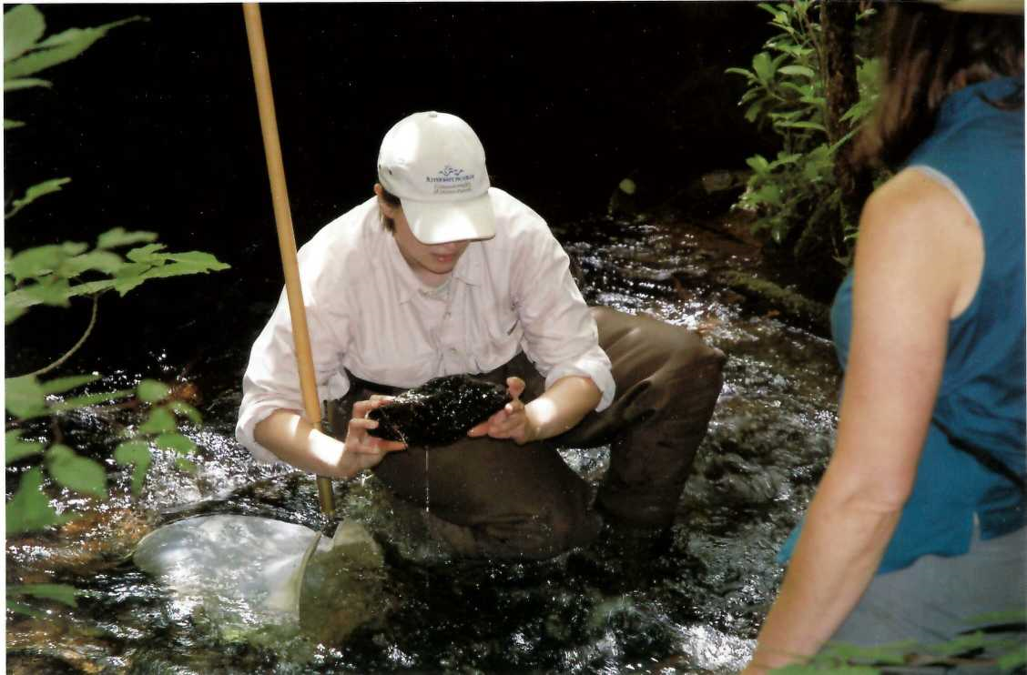
7 Carrie Banks teaches volunteers how to look for macro invertebrates.
NWSR Public Education and Outreach Strategies
 | Eight Mile | Farmington | Great Egg | Lamprey | Lower Delaware | Maurice | Musconetcong | Sudbury, Assabet & Concord | Taunton | Wekiva | Westfield | White Clay
Websites | ✓ | ✓ | ✓ | ✓ | ✓ | ✓ | ✓ | ✓ | ✓ | ✓ | ✓ | ✓
Printed Newsletters |  | ✓ | ✓ | ✓ | ✓ | ✓ | ✓ |  |  |  | ✓ | ✓
Web-based News & eBlasts |  |  |  |  | ✓ | ✓ | ✓ | ✓ |  | ✓
Youth Outreach | ✓ | ✓ | ✓ | ✓ | ✓ | ✓ | ✓ | ✓ | ✓ | ✓ | ✓ | ✓
Public Events | ✓ | ✓ | ✓ | ✓ | ✓ | ✓ | ✓ | ✓ | ✓ | ✓ | ✓ | ✓
Community Workshops | ✓ | ✓ | ✓ | ✓ | ✓ | ✓ | ✓ | ✓ | ✓ | ✓ | ✓ | ✓
Interpretive Panels & Waysides |  | ✓ | ✓ | ✓ |  | ✓ |  | ✓ |  |  | ✓ | ✓
Radio & Television | ✓ |  | ✓
Interactive Web Tools i.e. maps, blogs, etc. |  | ✓ |  |  |  | ✓ |  | ✓ |  | ✓ | ✓ | ✓
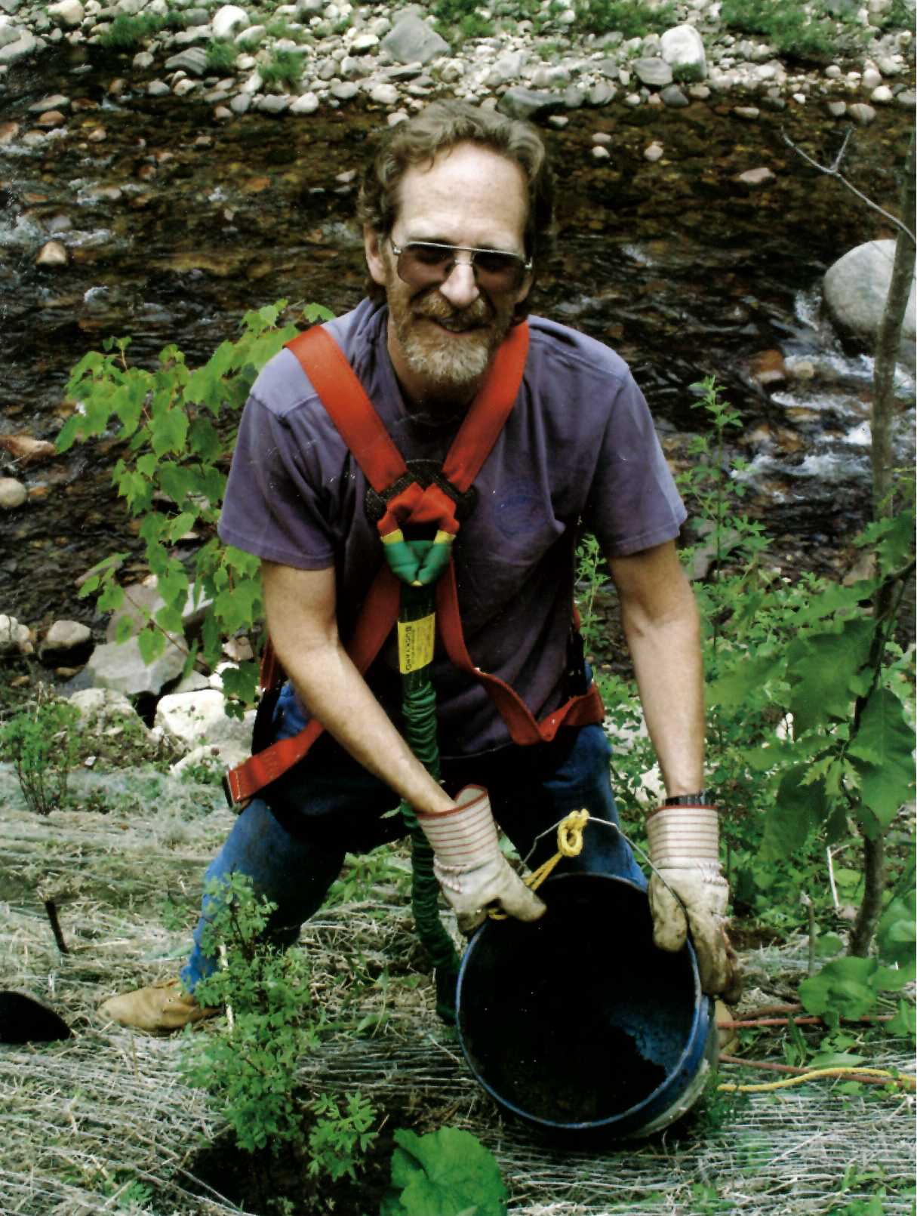
8 Volunteer Rob Draper helping with a stream bank stabilization project.

Rivers Depend on Volunteers
It was a college student who noticed the tire dump and brought it to the attention of Fred Akers, River Administer on the Great Egg Harbor River. Akers surveyed the site and raised money to cover the $1.70/tire fee involved in recycling the tires. Then Akers engaged volunteers from Water Watch, an organization that empowers volunteers to advocate for water quality, to collect and recycle the tires.
A success story, and an example of one way Partnership Rivers utilize volunteers. While each river employs volunteers in diverse ways, all river managers would probably agree with Beth Styler Barry, Executive Director of the Musconetcong Watershed Association, when she says, “We could not function without volunteers; they are absolutely essential to our activities.”
On many rivers, the people who contribute the most hours are those who are most closely associated with it. On the Great Egg, this means the Watershed Association staff. Akers estimated that his organization put in over 1,500 volunteer hours in 2008. On other rivers with less staff support, the steering committees are major sources of volunteer hours. Eileen Fielding, Executive Director of the Farmington River Watershed Association and member of the Farmington River Coordinating Committee (or frcc, which manages the Wild & Scenic River segment) said, “I was really impressed with how much time volunteers put in, communicating with people in other towns, and with other stakeholder groups.” frcc is primarily volunteer, and its members put in multiple hours of work. And, Fielding added, they’re in it for the long haul. It’s impressive, “not just to see how involved these people are, but for how many years they have been involved. Some have been on the committee for 10 or 15-years, which speaks of incredible dedication.”
Dependent as Partnership Rivers are on contributions of committee members, there is still a great need for community members to help with river clean-ups, pulling invasive species, stream walks, water quality testing, and more. Local volunteers are alerted to service opportunities on the rivers in multiple ways. Akers
has an e-mail announcement system to alert former volunteers. Styler Barry keeps track of the groups they’ve worked with before—“Boy Scout troops, church groups, environmental groups, high schools”—and contacts them with service opportunities. Meredyth Babcock, volunteer coordinator on the Westfield River, tries “to be a presence in the newspapers,” but she also takes a unique approach to getting volunteers. “I do a lot when I’m just out hiking,” she explained. I have pamphlets and information with me, and talk to everybody that I see, in hopes that they’ll become our eyes and ears on the river.”
Babcock’s position is unique—the Westfield River is the only Partnership River with a designated volunteer coordinator. Westfield River Wild and Scenic Coordinator Carrie Banks explains that having a volunteer coordinator gives them the ability to fully take advantage of their volunteer pool. “I think it’s important to have someone working with [volunteers] on a daily basis,” she says. “We’ve always found the key ingredient to being successful is having somebody willing to dedicate time and effort to coordinating volunteers, and following up with them.”
And, once the volunteers are organized, Babcock puts them to work. One of the main things volunteers do on the Westfield is called “Walking the Watershed.” Similar projects exist on many of the Partnership Rivers, with the main focus being “having people from different communities take care of the river.” The watershed walkers are given extensive training, which gives them a sense of what to look for, maps, and directions. Babcock says, “We ask them to bring into it whatever their interest and expertise is, be it geology or photography.” Together, the volunteers cover 78 river miles.
River walking, as well as picking up trash, pulling invasive species, and water quality testing, occur along all the rivers. Volunteers range from one-day volunteers, who participate in a river clean-up, to people who have been trained in water quality testing and take monthly samples year after year. These longtime volunteers have a depth of knowledge and are a great resource to the staff. Tom Stanton has been volunteering on the Farmington since 1992, He uses the river often, for boating and fishing. “I guess I volunteer because it is a beautiful resource and I enjoy it. Now I have two young children, and I’d like to protect it so they can use it.”

“We could not function without volunteers; they are absolutely essential to our activities.”
Beth Styler Barry
Executive Director of the Musconetcong Watershed Association

Total Volunteer Hours= 15,217.00 (approximately 634 full days)
Committees = 3678.00
Field Work = 4247.00
Water Quality Monitoring = 1290.00
Public Events = 3158.00 Other = 2849.00
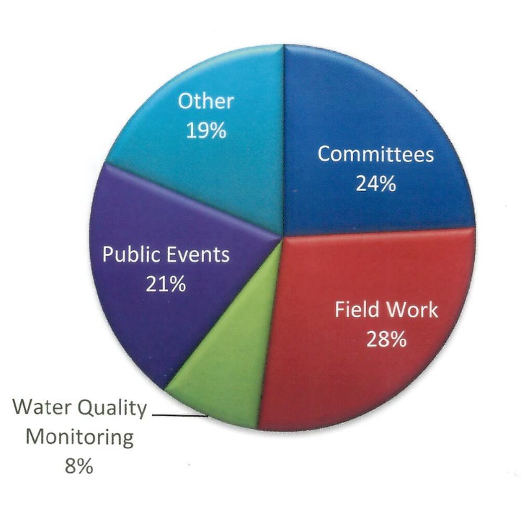
9 Volunteers range from one day volunteers, who participate in a river clean-up, to people who have been trained in water quality testing and take monthly samples year after year. These longtime volunteers have a depth of knowledge and are a great resource to the staff.
Linda Stapleford, River Administrator on the White Clay Creek, spoke of a volunteer who has been actively protecting the river since the late 1960’s, when there was a threat to dam the mainstream. “She continues to attend all the relevant meetings, reads everything in the paper, and is always alerting me to things,” Stapleford recalled. This volunteer alone estimates 300 volunteer hours a year.
But volunteers don’t need to have worked on the river for a long time to be invaluable. Styler Barry highlighted one Musconetcong volunteer, Chuck Gullage, who has been a river watcher for only three years. “He’s usually the first to step up when we have particular issues and takes the lead on emergency projects. “We had a diesel spill this year and Gullage made several trips to photograph the status over the weeks following the spill, made contact with employees [from the company responsible], and researched the kind of water oil separator tank that failed. He took on that project that went on for weeks.” River managers have also created relationships with nearby universities
to support protection efforts. In addition to working with Water Watch at Richard Stockton College, Akers also does environmental training at Rutgers University. “I decided to do an outdoor class” Akers explained. “All of a sudden I had the potential for twelve volunteers, and I put them right to work.” Akers had the students do a stream site biosurvey, the data from which was used by the Great Egg Harbor River Watershed Association.
Stapleford too, enjoys the advantages of being close to a University. The White Clay Creek River Administrator says it’s been very helpful “having the University of Delaware within our watershed boundaries. They have been a really active partner” focusing on projects on their campus, including their farm.” Stapleford explained that Tributaries originate on campus, flow through the farm, and into White Clay Creek. The University is, “experimenting with animal waste treatment, buffering streams, and channeling water There was a field that had been pretty wet all year,” Stapleford recalled. The field was “near a roadway, so it had a lot of public visibility, and the University created a wetland planted native species, and included some interpretive signs.” This is the headwaters and the goal is that as [the water] leaves the university property, it will be in good shape and attain all water quality standards.”
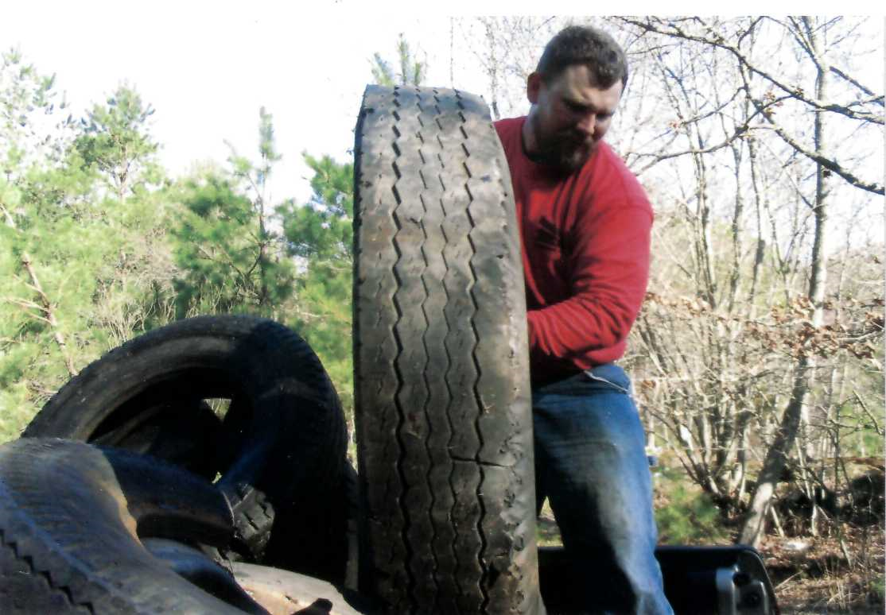
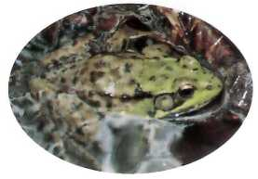
10 A frog watches volunteers at Glendale Falls in Middlefield.

Organizations, large and small, contribute volunteer efforts on the rivers. Nowhere is this more evident than at Riverfest on the Sudbury, Assabet, and Concord Rivers. The event takes place over one weekend and is comprised of over 50 different events aimed at getting people to explore the river in their own community. Coordinator for the Sudbury, Assabet, and Concord Wild & Scenic River Lee Steppacher explained, “I invite all kinds of local organizations to plan an event on the river that reflects who they are. All events are free to the public and each organization volunteers their time to plan and host their events.” The events range from hiking and canoe trips to poetry reading and choral singing. “It’s pretty easy to get those who enjoy the outdoors to participate, but we’d like to attract a broader audience—we’d like to include history, art, and music, so we reach out to a variety of groups and people.” Steppacher said. “Riverfest would not be possible without the contribution of volunteer time from so many.
I estimate well over 900 hours are contributed.”
Eileen Fielding appreciates the Wild and Scenic Partnership model and recognizes how
volunteers are essential to its success. “Once that little nugget of federal support is there,” she said, “in the form of a budget and contact with a National Park Service person, all the in-kind support gathers around that. It gets everybody talking to everybody else, about how to manage the river as a whole entity, rather than having things that stop at town boundaries.” As Fielding suggests, it is the volunteers that allow rivers to turn small amounts of funding into major projects. They help make the success of the Wild and Scenic Partnership Rivers possible.

Invasive Species: A Growing Threat
Job descriptions for managing river resources have expanded in the last decade to include management of invasive species. Rivers and their watersheds are threatened by plants and animals, including water chestnut, oriental bittersweet, carp and purple loosestrife. These non-native invasive species are disrupting ecological processes, diminishing recreational opportunities and threatening scenic vistas. The issue has grown so overwhelming so quickly, that it is hard to know where to begin to address it. While some advocate for inventorying and then protecting areas without infestation, others are trying to eradicate invasive species through early detection and rapid response, and perhaps the most pragmatic are primarily focused on managing the spread of these invaders. There are no clear or easy answers, although there are a number of stories to tell and lessons to learn.

Lamprey River Tackles Knotweed
When the Lamprey River Advisory Committee (lrac) realized that patches of Japanese knot- weed (Polygonum cuspidatum) were appearing along the Lamprey Wild & Scenic River, they teamed with the Lamprey River Watershed Association (lrwa) to launch an eradication effort. Beginning with conversation and web research about the plant and others’ experiences in controlling it, it quickly became obvious that this would be a difficult and long term project. The group decided to undertake a pilot project to test treatment strategies. Two Integrated Pest Management grants were received from the New Hampshire Division of Pesticide Control, and a consultant was hired to be part of the team. Initially, the group conducted an experiment in mechanical control at one site along the river, Wadleigh Falls. Volunteers cut knotweed and hauled it to a concrete pad at the dump, while other areas were covered with cardboard and a thick layer of mulch. Neither of these methods produced any noticeable results come the following spring.
The next step was to test herbicide treatment methods. Permits and landowner permissions were acquired and a licensed pesticide applicator was hired to treat knotweed
stands in two different towns. In areas ten feet from the river’s edge, glyphosate was injected. The rest was sprayed with Imazapyr (because of labeling laws in New Hampshire, Glyphosate could not be used). In the following season (summer 2009) it was observed that the ten-foot buffer injection was only marginally successful, while the sprayed area was approximately 90% successful. However, a number of trees and shrubs were killed too.
The pilot project continues with plans to re-treat the areas from last year and treat a new knotweed site at the headwaters of the river. The project also launched an online map and questionnaire where the public is reporting other knotweed populations throughout the watershed. Stay tuned....

Sudbury, Assabet and Concord Rivers Create a CISMA
It was over lunch at a meeting in 2005 that a group of activists from the Concord watershed realized how much they had in common as they discussed the difficulties of controlling invasive species on their properties. They commiserated about the large number of species they were finding, the difficulties in controlling them, the challenge of training volunteers to help with management efforts and the general lack of knowledge by the public about the threat these species posed. From their shared misery came a commitment to meet together for further sharing of ideas, and ultimately the mutual support of the CISMA! The CISMA (Cooperative Invasive Species Management Area, also known as a Cooperative Weed Management Area in other parts of the Country) is an approach to invasive species management used, until recently, primarily in the western U.S. The CISMA was formed to cover a particular geographic area—the Concord Watershed, and to coordinate government agencies, conservation commissions, land trusts, advocacy groups and other non profits. Already 23 organizations have committed and “signed-on.” The CISMA offers means to work together, especially on properties that share boundaries; it provides a place to share information and volunteers; and it provides a structure to apply for grants. The CISMA has received funding from the National Fish and Wildlife Foundation, The Sudbury Foundation and the River Stewardship Council.
Wild & Scenic River managers and partners have reached the same conclusion: If we do not take on this difficult issue, then who will?
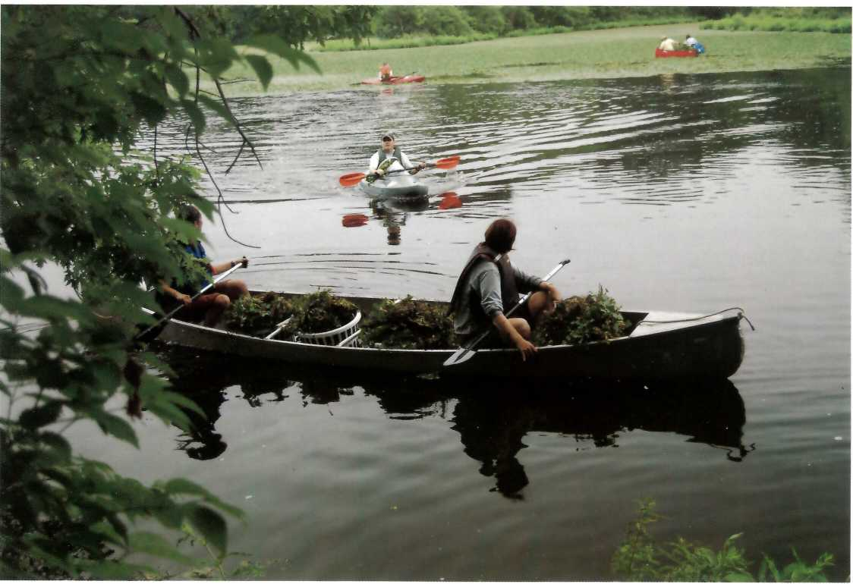
11 Water Chestnut found on the Concord River.

Farmington River Invasive Plant Assessment
The Farmington River Coordinating Committee (frcc) has been concerned about the spread of non-aquatic, non-native invasive plants encroaching upon the 14-mile Wild & Scenic River corridor, as Japanese knotweed and garlic mustard, among others, have appeared and spread. As part of an effort to understand what species have invaded and what methods could be used to manage them, the Committee hired a consulting botanist, Betsy Corrigan, to examine the river corridor and its environs. Assisted by intern Tiffany Caisse of Westfield State College, Corrigan developed a series of gis aerial maps depicting the infestations of plants. These gis maps were coded to show the areas of plant communities and the extent of the growth in each location. Along with the maps is an extensive list of species and potential level of threat. The survey was completed recently, and in 2010, the frcc will contract again with Corrigan to follow up on recommendations from her report.
One primary recommendation is to use a regional coordinated approach like the Sudbury Assabet Concord River (cisma). Another priority is to direct frcc’s efforts to areas where it will be most effective in protecting rare species. Corrigan also suggests addressing the “new arrivals” in the area and controlling them before they really take “root.” frcc will also work with Corrigan to train volunteers and land- owners to work on controllable species.
In each of these cases, Wild & Scenic River managers and partners have reached the same conclusion: If we do not take on this difficult issue, then who will? Track progress through the river’s websites.

White Clay Creek Watershed: A Reservoir for Restoration & Education
The White Clay Creek watershed is 107 square miles and includes 190 miles of streams designated as part of the National Wild & Scenic Rivers system. Nearly 100,000 people in Chester County, Pennsylvania and New Castle County, Delaware call the White Clay Creek watershed home and rely on its exceptional aquifers for drinking water. Sandwiched between the major urban centers of Philadelphia, Pennsylvania; Wilmington, Delaware; and Newark, Delaware, the White Clay watershed is in comparison a relatively undeveloped and scenic area—an increasing rarity in the region.
Because of the relative availability and feasibility of sites for ecological restoration within the watershed, the U.S. Army Corps of Engineers (USACE), Chester County Conservation District, and Delaware Department of Natural Resources and Environmental Control (DNREC) have increasingly looked to the area for potential mitigation of environmental impact in other areas, USACE, through its regulatory program (Section 404 of the Clean Water Act and Section 10 of the Rivers and Harbors Act of 1899), may require permittees to compensate for unavoidable losses to waters of the
United States, including jurisdictional wetlands. The permitting process may allow for opportunities to look within the White Clay Creek watershed for compensatory mitigation sites.
DNREC in particular has made a concerted effort to provide applicants for water quality permits with mitigation options through its restoration program along Pike Creek, a designated tributary of White Clay Creek Scenic & Recreational River. A recent example involves the New Castle County Airport that, in 2004 applied to USACE for approval to perform Federal Aviation Administration (FAA) required safety improvements to the Runway 1-19 runway safety area. These improvements involved the discharge of fill materials within 2.2 acres of regulated wetlands and waterways. On-site options for mitigation sites were not considered, as the FAA will not fund such sites if they are located within 10,000 linear feet of the end of the runway. The FAA considers wetlands a safety issue due to the potential for attracting birds. 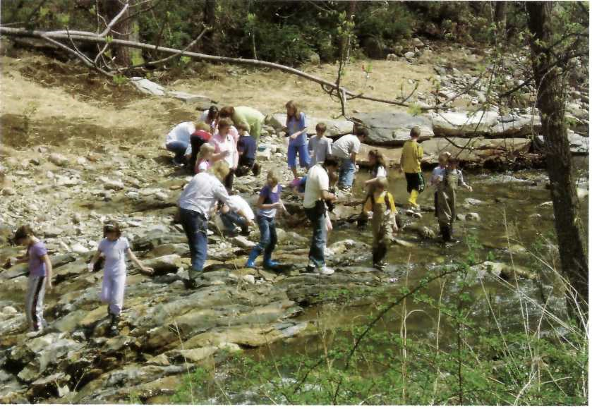
12 Despite (or perhaps, because of) the challenges of successfully recreating viable, naturally functioning wetlands and restoring streams, these two projects provide excellent educational and interpretive opportunities for students, teachers and the surrounding communities. In the case of Independence School, the students and their teachers use the mitigation project as an outdoor classroom.
A partnership among DNREC’s Division of Soil and Water, DRBA, and Independence School, the mitigation project used a 3.8-acre portion of the school for the creation of a wetland and stream restoration along Pike Creek. Excess flow from a minor tributary of Pike Creek was partially diverted to the wetland for storm water and water quality management. Now in its second year of the USACE-required minimum five years for monitoring, the artificially created wetland is evolving with a good diversity of woody, emergent and scrub-shrub vegetation and seems to be functioning largely as anticipated. Deer damaged some of the seedlings planted during their first year; however, the plants re-sprouted and the mortality rate was relatively low.
The permittee is currently addressing the following major issues: management of exotic plant species that invade from adjoining areas and from existing seed in the mitigation site soils; repairing minor gully erosion in one corner of the mitigation site; overtopping of Pike Creek’s banks, resulting in debris entering the wetland and washout behind one structure; and potential impacts from future maintenance to an existing sanitary sewer line that runs through the project area.
A second project, not yet under construction, includes mitigation for Norfolk Southern Corporation’s railroad expansion near the Port of Wilmington, at Lands of Autoport, Inc. that would impact more than half an acre of wetlands regulated by usace. Relocating the railroad was not practical, given the location of the right-of-way within an industrial area and the project objective to increase the capacity to load and unload rail cars at the Port.
A mitigation site was located on University of Delaware property along Cool Run, a tributary of the White Clay Creek in Newark. 1.56 acres of pasture land abutting Cool Run will be restored as riparian forest, a type of wetland which has suffered major losses in Delaware. Existing reed canary grass, an invasive species, will be removed, and a combination of warm season grasses, emergent vegetation, and native trees will be planted, creating a wooded wetland corridor approximately 250 feet wide on either side of Cool Run.
The mitigation project supports the efforts of the University of Delaware’s Watershed Action Team for Ecological Restoration to restore the headwaters of Cool Run as part of its watershed action plan. The project will positively impact the White Clay Creek, helping to reduce storm water runoff containing pollutants from
adjacent roads and the agricultural lands, reducing downstream flooding that erodes the stream banks, and allowing for ground- water recharge and flood control. Additionally, an expanded buffer of native wetland vegetation along the pasture lands will provide wildlife habitat.
Perhaps it is no accident that the two mitigation projects are both associated with educational institutions. Despite or perhaps because of the challenges of successfully recreating viable, naturally functioning wetlands and restoring streams, these two projects provide excellent educational and interpretive opportunities for students, teachers and the surrounding communities. In the case of Independence School, the students and their teachers use the mitigation project as an outdoor classroom. The creation of a forested wetland on University of Delaware property provides' additional educational opportunities for the cross-disciplinary Watershed Action Team that includes student interns, in collaboration with the City of Newark.
Could there be an opportunity for a “mitigation bank” in the White Clay Creek watershed? The outstanding resources for which the White Clay Creek was originally designated a Wild & Scenic River include a diversity of species in a variety of ecosystems, the creek’s importance as a source of drinking water, and a number of public and private preserves that conserve about 10% of the watershed’s open space. Projects that protect, enhance, and restore these resources are supported in the White Clay Creek Watershed Management Plan.
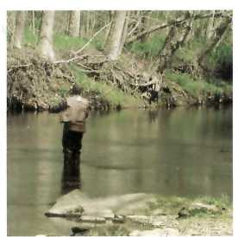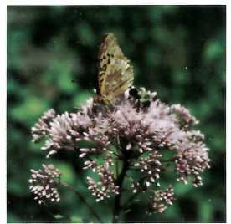
13 (Left) Fly Fishing on the White Clay Creek and (Right) Sharing sweetness along the riverbank of the White Clay Creek
NOTE: In 2008 the U.S. Army Corps of Engineers and U.S. Environmental Protection Agency released a new rule (Federal Register / Vol. 73, No. 70 / Thursday, April 10, 2008 I Rules and Regulations, Compensatory Mitigation for Losses of Aquatic Resources; Final Rule) to clarify how to provide compensatory mitigation for unavoidable impacts to the nation's wetlands and streams. You can find the new Compensatory Mitigation Rule in the Federal Register or on-line at: http://www.USACE.army.mil/cw/cecwo/reg/ or http:// www.epa.gov/wetlandsmitigation.
National Park Service – U.S. Department of the Interior
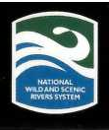
National Park Service  U.S. Department of the Interior  200 Chestnut Street Philadelphia, Pennsylvania 19106  Lower Delaware River  Lower Delaware Wild & Scenic Management Committee www.LowerDelawareWildandScenic.org NPS Contact: Julie Bell  215.597.6473  Julie_Bell@nps.gov  Eightmile River  Eightmile River Wild & Scenic Coordinating Committee  www.EightmileRiver.org  Local Contact: Pat Young  860.345.8700  PYoung@eightmileriver.org  NPS Contact: Jamie Fosburgh  617.223.5191  Jamie_Fosburgh@nps.gov  Farmington River  Farmington River Coordinating Committee  www.FarmingtonRiver.org  NPS Contact: Liz Lacy  860.379.0282  Liz_Lacy@nps.gov  Lower Farmington River  Lower Farmington Study River Committee  www.LowerFarmingtonRiver.org  NPS Contact: Joyce Kennedy  860.658.4442 ext. 203  Joyce_Kennedy@nps.gov  Great Egg Harbor River  Great Egg Harbor River Watershed Association  www.gehwa.org  Local Contact: Fred Akers  856.697.6114  Akers@gowebway.com  NPS Contact: Paul Kenney  215.597.5823  Paul_Kenney@nps.gov  Lamprey River  Lamprey River Advisory Committee  www.LampreyRiver.org  NPS Contact: Jim McCartney  603.226.3436  Jim_McCartney@nps.gov  Maurice River  Citizens United to Protect the Maurice River and  It's Tributaries, Inc.  www.CUMauriceRiver.org  Local Contact: Jane Morton Gaietto  ForRivers@aol.com  NPS Contact: Paul Kenney  215.597.5823  Paul_Kenney@nps.gov | Upper Missisquoi and Trout Rivers  Upper Missisquoi and Trout Rivers Wild & Scenic  Study Committee  www.vtwsr.org  Local Contact: Shana Stewart  802.393.0076  Shana.Stewart@vtwsr.org  NPS Contact: Jamie Fosburgh  617.223.5191  Jamie_Fosburgh@nps.gov  Musconetcong River  Musconetcong Watershed Association  www.musconetcong.org  Local Contact: Beth Styler Barry  908.537.7060  Beth@musconetcong.org  NPS Contact: Paul Kenney  215.597.5823  Paul_Kenney@nps.gov  Sudbury, Assabet & Concord Rivers  Sudbury, Assabet & Concord Rivers Stewardship Council www.Sudbury-Assabet-Concord.org NPS Contact: Lee Steppacher 617.223.5225  Lee_Steppacher@nps.gov  Taunton River  Taunton River Stewardship Council  www.TauntonRiver.org  Contact: Jamie Fosburgh  617.223.5191  Jamie_Fosburgh@nps.gov  Wekiva River  www.rivers.gov/wsr-wekiva.html  Local Contact: Nancy Prine  407.898.9200  npla@aol.com  NPS Contact: Jaime Doubek-Racine  941.330.0069  Jaime_Doubek-Racine@nps.gov  Westfield River  Westfield River Wild & Scenic Advisory Committee  www.WestfieldRiverWildScenic.org  Local Contact: Carrie Banks  413.286.3129  coordinator@westfieldriverwildscenic.org  NPS Contact: Liz Lacy  860.379.0282  Liz_Lacy@nps.gov  White Clay Creek  White Clay Watershed Management Committee  www.WhiteClay.org  Local Contact: Linda Stapleford  302.731.1756  RiverAdministrator@whiteclay.org  NPS Contact: Julie Bell  215.597.6473  Julie_Bell@nps.gov

For more information please visit: www.nps.gov/pwsr
EXPERIENCE YOUR AMERICA™

