**Hydropower Project Summary**

# Deerfield River, VT and MA

Deerfield HYDROELECTRIC PROJECT (P-2323)

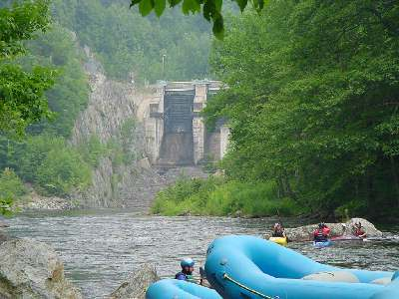

Photo courtesy of American Whitewater

Deerfield No. 4

*This summary was produced by Susan Taft for*

Hydropower Reform Coalition

*and*

River Management Society

# Deerfield River, VT and MA

Deerfield HYDROELECTRIC PROJECT (P-2323)

Project Significance:

The Deerfield River settlement agreement was the first major relicensing agreement in the northeast and the second agreement ever signed in the U.S. Signed in 1994, it became the model for re-licensing agreements that followed across the country that brought together a diversity of groups interested in protecting fisheries, wildlife habitat, water-based recreation, land protection and water quality to work with FERC staff and project owners. This diversity is illustrated in the range of stakeholders that comprise the thirteen signatories to the Deerfield River settlement agreement. Some of the key aspects of the settlement include:

* Stable reservoir levels to protect loon and waterfowl nesting (Somerset)
* Guaranteed flows to mimic natural flows for cold water fishery and Atlantic Salmon spawning
* Whitewater recreational access and flows providing 32 releases from April to October
* Flow release information (Flofone) available 24 hours/day
* More than 8,000 acres of land preserved including improved access and hiking trails
* $100,000 Enhancement Fund for watershed conservation, education and low impact recreational projects.

Description***:***

The Deerfield Project is located on the Deerfield River in Windham and Bennington Counties in Vermont, and Franklin and Berkshire Counties in Massachusetts. It consists of eight developments in total, three in Vermont (Somerset, Searsburg, and Harriman) and five in Massachusetts (Sherman, Deerfield No. 5, Deerfield No. 4, Deerfield No. 3, and Deerfield No. 2), all located between river miles 13.2 and 66 on the Deerfield River [See **Figure 1**].

The thirteen signatories to the Settlement are: New England Power[1]; the U. S. Environmental Protection Agency; the National Park Service; the U. S. Fish and Wildlife Service; the Massachusetts Division of Fisheries and Wildlife; American Rivers, Inc.; American Whitewater Affiliation; the Appalachian Mountain Club; the Conservation Law Foundation; the Deerfield River Compact; the Deerfield River Watershed Association; New England FLOW; and Trout Unlimited.

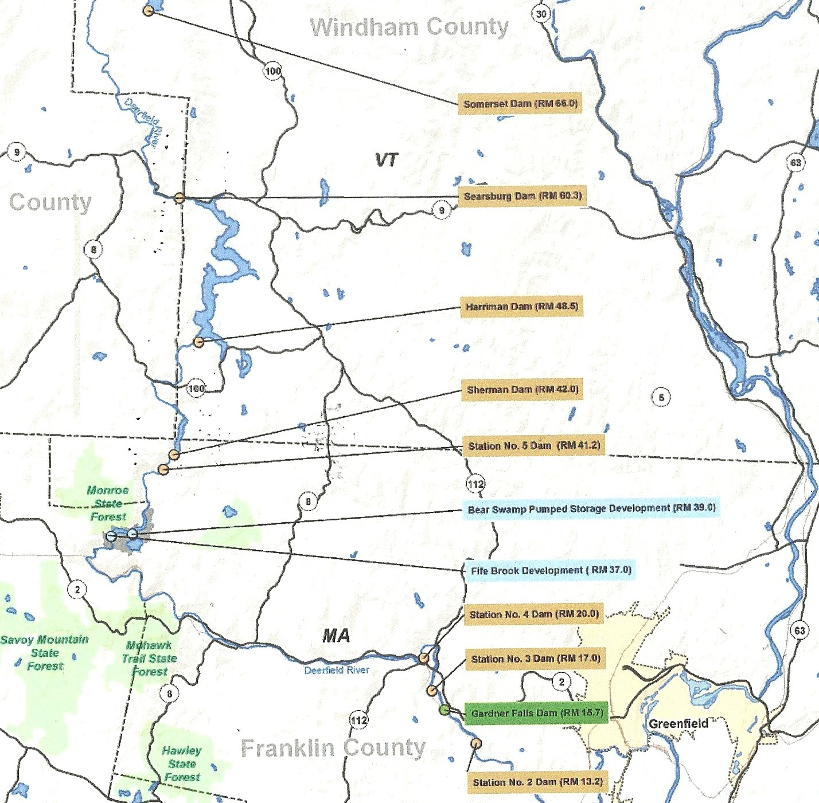

**Figure 1**: The Eight Deerfield Projects (*highlighted in tan*)

Bear Swamp Power Company LLC

1. SUMMARY
2. License application filed: October 6, 1994
3. License Issued: April 4, 1997
4. License expiration: March 31, 2037
5. Waterway: Deerfield River
6. Capacity: 76.9 megawatt (MW)
7. Licensee: Great River Hydro, LLC
8. Licensee address: 40 Pleasant Street, Suite 202

Portsmouth, NH 03801

1. Counties: Windham and Bennington Counties in Vermont; Franklin and Berkshire Counties in Massachusetts
2. Project area: The project area includes 8 dams and storage reservoirs. The farthest upstream developments are in Vermont and include the Somerset Dam with gross surface area reservoir of 1,514 acres followed by the Searsburg Dam with an area of 30 acres and the Harriman Dam with a surface area of 2,039 acres. The next downstream development is the Sherman Dam (the most upstream development in Massachusetts) with a reservoir with a surface area of 218 acres, followed by Deerfield No. 5, Deerfield No.4, Deerfield No. 3, and Deerfield No. 2 with surface areas of 38 acres, 75 acres, 42 acres, and 63.5 acres, respectively.
3. Project Facilities (starting farthest upstream):
4. Somerset
   * an earth-fill dam structure about 110 feet high and 2,101 feet long with a crest elevation of 2133.58 feet mean sea level (msl);
   * main outlet works located at the eastern end of the dam which consists of two gated, 48-inch diameter pipes that are used to control reservoir discharge;
   * a side channel spillway about 800 feet long, 45 feet wide, and from six to 30 feet deep, located at the western end of the dam with a crest elevation of 2133.58 feet msl;
   * a reservoir about 5.6 miles long with a gross surface area of about 1,514 acres, a gross storage capacity of 57,345 acre‑feet, a usable storage capacity of 20,614 acre-feet, and a normal pool headwater elevation range of 2,113.10 to 2,128.10 feet msl.
5. Searsburg

* an earth-fill dam structure about 50 feet high and 475 feet long with a 137 foot-long concrete gravity spillway, with a crest elevation of 1749.66 feet msl (from May 1 to October 31), topped with 5-foot flashboards;
* an intake and penstock with a wood stave conduit 8 feet in diameter and 18,412 feet long, a steel differential surge tank 50 feet in diameter and 34 feet high, and a steel penstock 6.5 feet in diameter and 495 feet long;
* a powerhouse containing one vertical Francis turbine unit with a capacity of 4,160 kilowatts (KW);
* a reservoir about 0.9 miles long, with a surface area of about 30 acres, a gross storage capacity of 412 acre-feet, a usable storage capacity range of 67 to 197 AF, and a normal pool elevation range of 1746.66 to 1754.66 feet msl;
  + appurtenant facilities.

1. Harriman

* an earth-fill dam 215.5 feet high and 1,250 feet long;
* a storage reservoir nine miles long, having a surface area of about 2,039 acres, a gross storage capacity of 117,300 acre-feet, a usable storage capacity of 103,375 acre-feet (from elevation 1405.66 to 1491.66 feet msl), and a normal pool headwater elevation of 1449.70 to 1491.66 feet msl;
* morning glory spillway with sixteen gates at a sill elevation of 1491.66 msl, topped with six-foot-high flashboards;
* two eight-foot diameter valves; a 12,812-foot long, 14-foot-diameter concrete lined horseshoe shaped intake tunnel; a steel differential surge tank 34 feet in diameter and 184 feet high; and three steel penstocks nine feet in diameter and 620 feet long;
* a powerhouse containing three vertical Francis turbine units with a total hydraulic capacity of 1,600 cubic feet per second (cfs), and a capacity of 11,200 KW each;
* appurtenant facilities.

1. Sherman
   * a 110-foot-high 810-foot-long earth-fill dam, with a crest elevation of 1129.66 feet msl;
   * a 179-foot-long concrete gravity spillway, with a crest elevation of 1103.66 feet msl, topped with four-foot-high flashboards which operate year-round;
   * a concrete and brick intake structure and penstock which conveys water to the powerhouse via a concrete conduit 98 feet in length with a cross-sectional area of 142 square feet, and a steel penstock 13 feet in diameter and 227 feet long;
   * a reservoir about two miles long, with surface area of about 218 acres, gross storage capacity of 3,593 acre-feet, useable storage capacity of 1,359 acre-feet, and a normal pool headwater elevation range of 1104.66 to 1107.66 feet msl;
   * a powerhouse containing one vertical Francis turbine unit with a capacity of 7,200 kW;
   * appurtenant facilities.
2. Deerfield No. 5 (farthest upstream in Massachusetts)
   * a dam comprised of a concrete gravity spillway about 35 feet high and 90 feet long, with a top elevation of 1,109.66 feet msl, topped with eight-foot-high hydraulic steel flap gates which maintain a normal reservoir elevation of 1027.66 feet msl, a concrete intake structure, consisting of two eight-foot wide by 7.75 foot-high sluice gates, with a sill elevation of 1002.28 feet msl, and a single 12.5 foot by 13-foot intake gate with a sill elevation of 1008.16 msl;
   * a small concrete gravity diversion structure on Dunbar Brook approximately 12 feet high and 160 feet long;
   * conveyance sections of tunnel, concrete conduit, and canal totaling 14,941 feet;
   * a steel penstock ten feet in diameter and 400 feet long;
   * a reservoir about 0.75 miles long, having a surface area of about 38 acres, a storage capacity of 118 acre-feet, and a normal pool headwater elevation range of 1022.66 to 1026.66 feet msl;
   * a powerhouse containing one vertical Francis turbine unit with a capacity of 17,550 KW and a hydraulic capacity of 1,250 cfs;
   * a switchyard located on River Road across from the Bear Swamp Visitor's Center;
   * appurtenant facilities.
3. Deerfield No. 4
   * an earth-fill dam (with a concrete core) about 50 feet high and 160 feet long;
   * a 241 foot-long concrete gravity spillway with a crest elevation of 465.66 feet msl, topped with six eight-foot-high wooden flashboards;
   * three sluice gates located in the east abutment, two with a sill elevation of 462.66 feet msl and another with a sill elevation of 464.66 feet msl: a reservoir about two miles long, having a surface area of about 75 acres, a gross storage capacity of 467 acre-feet, and a usable storage capacity of 432 acres, and a normal pool headwater elevation range of 465.66 to 473.66 feet msl;
   * a power tunnel which conveys water from the intake structure at the impoundment via a 12.5-foot diameter, 1,514-foot-long concrete and brick-lined horseshoe shaped tunnel that leads to the powerhouse forebay;
   * a powerhouse containing three horizontal Francis turbine units with a capacity of 1,600 KW each, and a hydraulic capacity of 1,490 cfs;
   * appurtenant facilities.
4. Deerfield No. 3
   * a concrete gravity spillway about 15 feet high and 475 feet long with a crest elevation of 396.66 feet msl, topped with six-foot-high wooden flashboards;
   * two sluice gates;
   * a power tunnel 677 feet long, 17 feet wide by 12.5 high concrete conduit;
   * a reservoir about 1.3 miles long, having a surface area of about 42 acres, a gross storage capacity of 221 acre-feet, a usable storage capacity of 200 acre-feet and a normal pool headwater elevation range of 396.66 to 402.66 feet msl;
   * a powerhouse containing three horizontal Francis turbine units with a capacity of 1,600 KW each and a hydraulic capacity of 1490 cfs;
   * a switchyard located within the powerhouse;
   * appurtenant facilities.
5. Deerfield No. 2:
   * a concrete gravity spillway about 15 feet high and 475 feet long with a crest elevation of 396.66 feet msl, topped with six-foot-high wooden flashboards;
   * two sluice gates;
   * a power tunnel 677 feet long, 17 feet wide by 12.5 high concrete conduit;
   * a reservoir about 1.3 miles long, having a surface area of about 42 acres, a gross storage capacity of 221 acre-feet, a usable storage capacity of 200 acre-feet and a normal pool headwater elevation range of 396.66 to 402.66 feet msl;
   * a powerhouse containing three horizontal Francis turbine units with a capacity of 1,600 KW each and a hydraulic capacity of 1490 cfs;
   * a switchyard located within the powerhouse;
   * appurtenant facilities.
6. Important Provisions and Requirements in License

The license requires a number of measures to protect and enhance fish, wildlife, recreation, vegetation, cultural, and aesthetic resources at the project. The more significant provisions of this license impacts flows for upstream passage for Atlantic salmon; loon nesting; preservation of the tubercled orchid, a state listed rare species; whitewater; fishing; and a conservation easement.

1. Fish and Wildlife[Reference: *License Articles 401 through 418, 420, and 421*]  
   A series of plans for water level management that impact fish and wildlife are included in the License.
   1. *Articles 401 and 402*: Manage Somerset reservoir levels from May 1 to Sept 1 to protect nesting common loons.
   2. *Articles 403 and 404*: Manage maximum Somerset discharge ramping rates into the river. August 1 to April 1 up-ramping rate not to exceed 100 cfs over 24 hours, down-ramping rate not to exceed 50 cfs over 24 hours.
   3. *Articles 405, 406 and 412*: Manage minimum river flows for the protection of fish and aquatic resources:

|  |  |  |
| --- | --- | --- |
| Project | Minimum Flow | Time Period |
| Somerset | 30 cfs | Oct 1 – Dec 15 |
| 48 cfs | Dec 16 – last day of Feb |
| 30 cfs | Mar 1 – April 30 |
| 9 cfs | May 1 – Sept 30 |
| Max gate release of 312 cfs, or instantaneous inflow if higher | |
| Searsburg | 35 cfs or inflow whichever is less | June 1 – Sept 30 |
| 55 cfs or inflow whichever is less | Oct 1 – May 31 |
| 175 cfs | Apr 20 – May 15 |
| Harriman | 70 cfs | Oct 1 – June 30 |
| 57 cfs | July 1 – Sept 30 |
| Deerfield No. 5 | 73 cfs or inflow whichever is less. At no time less than 57 cfs released from Harriman. | |
| Deerfield No. 4 | 100 cfs or inflow whichever is less | Oct 1 – May 31 |
| 125 cfs or inflow whichever is less | June 1 – Sept 30 |
| Deerfield No. 3 | 100 cfs or inflow whichever is less | Year round |
| Deerfield No. 2 | 200 cfs | Year round** |

** For Deerfield No. 2 (*Article 412*), the changes from 200 cfs minimum to generation flows are to occur on an average of no more than 2 times per day and not more than 10 times per week.

1. *Articles 407 through 411 and 413:* Construct fish passage facilities at Deerfield No. 2, 3 and 4 for Atlantic salmon and monitor effectiveness of facilities and associated operational flows. Implement Atlantic Salmon radio-tagging, or an alternative method, to determine the numbers of salmon reaching Deerfield No. 2 as part of determining the effectiveness of facilities and associated operational flows.
2. *Articles 414 and 415:* Monitor water quality (dissolved oxygen and temperature) to gage the effectiveness of facilities, reservoir water levels and flow levels to protect fisheries
3. *Articles 416 through 418, 420 through 422:* Implement plans to revise the existing watershed model to better predict the timing and volume of inflows to the Somerset and Harriman reservoirs to reduce winter drawdown to levels needed to capture spring runoff; develop rating curves depicting the head-flow to power relationship for Somerset, Searsburg, and Harriman projects; plan and monitor trashracks at Searsburg to reduce fish impingement and entrainment; implement artificial nesting plan for waterfowl populations at Somerset; implement a beaver management plan; and, implement a forest/timber management plan.
4. **Threatened and Endangered Species**
   1. *Article 419*: Mitigation and monitoring of the effectiveness of relocating and maintaining tubercled orchids (Platanthera flava), an endangered species, that had established itself in areas around the Harriman and Searsburg facilities that had been bypassed (de-watered) prior to the implementation of the river flows in this license.
5. Recreation [Reference: *License Articles 423 through 426*]  
   The license requires a supplemental plan to the Comprehensive Recreation Plan, construction of new recreational facilities, an Instream Recreation Study, and recreational releases.
   1. *Article 423*: The license requires a supplemental plan to the Comprehensive Recreation Plan to include appropriate vegetation and erosion control measures associated with improvements to existing and construction of new recreation facilities along with regularly scheduled monitoring and maintenance of recreational use areas.
   2. *Article 424:* Construct and maintain a portage at the Searsburg dam and a put-in below the dam.
   3. *Article 425:* Implement an Instream Recreation Study to examine the need for establishing grade flow rate change (ramping rates) downstream of the Deerfield River projects or the need to add additional alarm systems for the safety of recreational users.
   4. *Article 426:* Implement recreational releases from Deerfield No. 5 for whitewater boating annually for a total of 26 weekend days or holidays and 6 Fridays from May to October 31 for the following hours and monthly allocation:

* Fridays- at least 4 continuous hours starting at 11:00 am
* Saturdays- at least 5 continuous hours starting at 10:00 am
* Sundays- at least 4 continuous hours staring at 10:00.

The flow levels are 900, 1000, and 1100 cfs distributed equally so that the average is 1000 cfs.

|  |  |
| --- | --- |
| Month | Allocation** |
| May | 2 weekend days |
| June | 5 weekend days and 2 Fridays |
| July | 6 weekend days and 2 Fridays |
| August | 7 weekend days and 2 Fridays |
| September | 4 weekend days |
| October | 2 weekend days |

** Holidays may be substituted for weekend days upon agreement between the Licensee and citizen groups including New England FLOW representing the whitewater boating community before April 1 of each year.

The Licensee is required to meet with representative citizen groups including New England FLOW before January 1 of each year to cooperatively develop the whitewater release schedule by April 1 for cooperation in the dissemination of the release schedule.[2]

Provisions are included for the reduction of flow releases due to natural low water conditions to cooperatively arrive at a reduced schedule, notification to the public, and rescheduling of canceled release dates as additional release dates over the next 2 years.

1. Conservation[Reference: *License Article 427*]

Implement Conservation Easement Plan for the protection of scenic, forestry and natural resources on 16,627 acres of land in the Deerfield River Project boundary, 421 acres of land downriver of the Deerfield No.2 development, 17,098 acres of conservation easements that includes 15,736 acres of land in Vermont, and 1,362 acres of land in Massachusetts.

1. Environmental Enhancement Fund [Reference: *License Article 429*]

Implement the Deerfield Basin Environmental Enhancement Fund in the amount of $100,000 (a one-time funding) to finance watershed conservation, development of low impact recreational and educational projects and facilitate planning, design, maintenance and monitoring of such facilities as described in the Settlement.

1. MAP

For additional information on this project and to see a map of the project area, please visit the Hydropower Reform Coalition website at <https://hydroreform.org/on-your-river/?fwp_project_search_v2=deerfield>.

There is additional information, including how to access this project on the FERC eLibrary, on the River Management Society website at [www.river-management.org/hydropower-projects](https://www.river-management.org/hydropower-projects).

1. Ownership of the projects changed multiple times since the agreement settlement was signed. As of 2017, the owner is Great River Hydro, LLC. All new owners are required to uphold the license agreement.
2. Provisions require the flow information is available by telephone with recorded flow information and anticipated release schedules that is updated daily by the Licensee during the whitewater boating season. However, this phone number is no longer in service as up to date information is available online, including at <http://deerfieldriver.org/recreation/flows/>.