Outreach

Zoned Forestry Technician

(Developed Recreation, Wild & Scenic Rivers, Trails, and Wilderness)

Detail / Permanent Position

GS-0462-7
Gold Beach and Powers Ranger Districts
Rogue River - Siskiyou National Forest
Gold Beach, OR

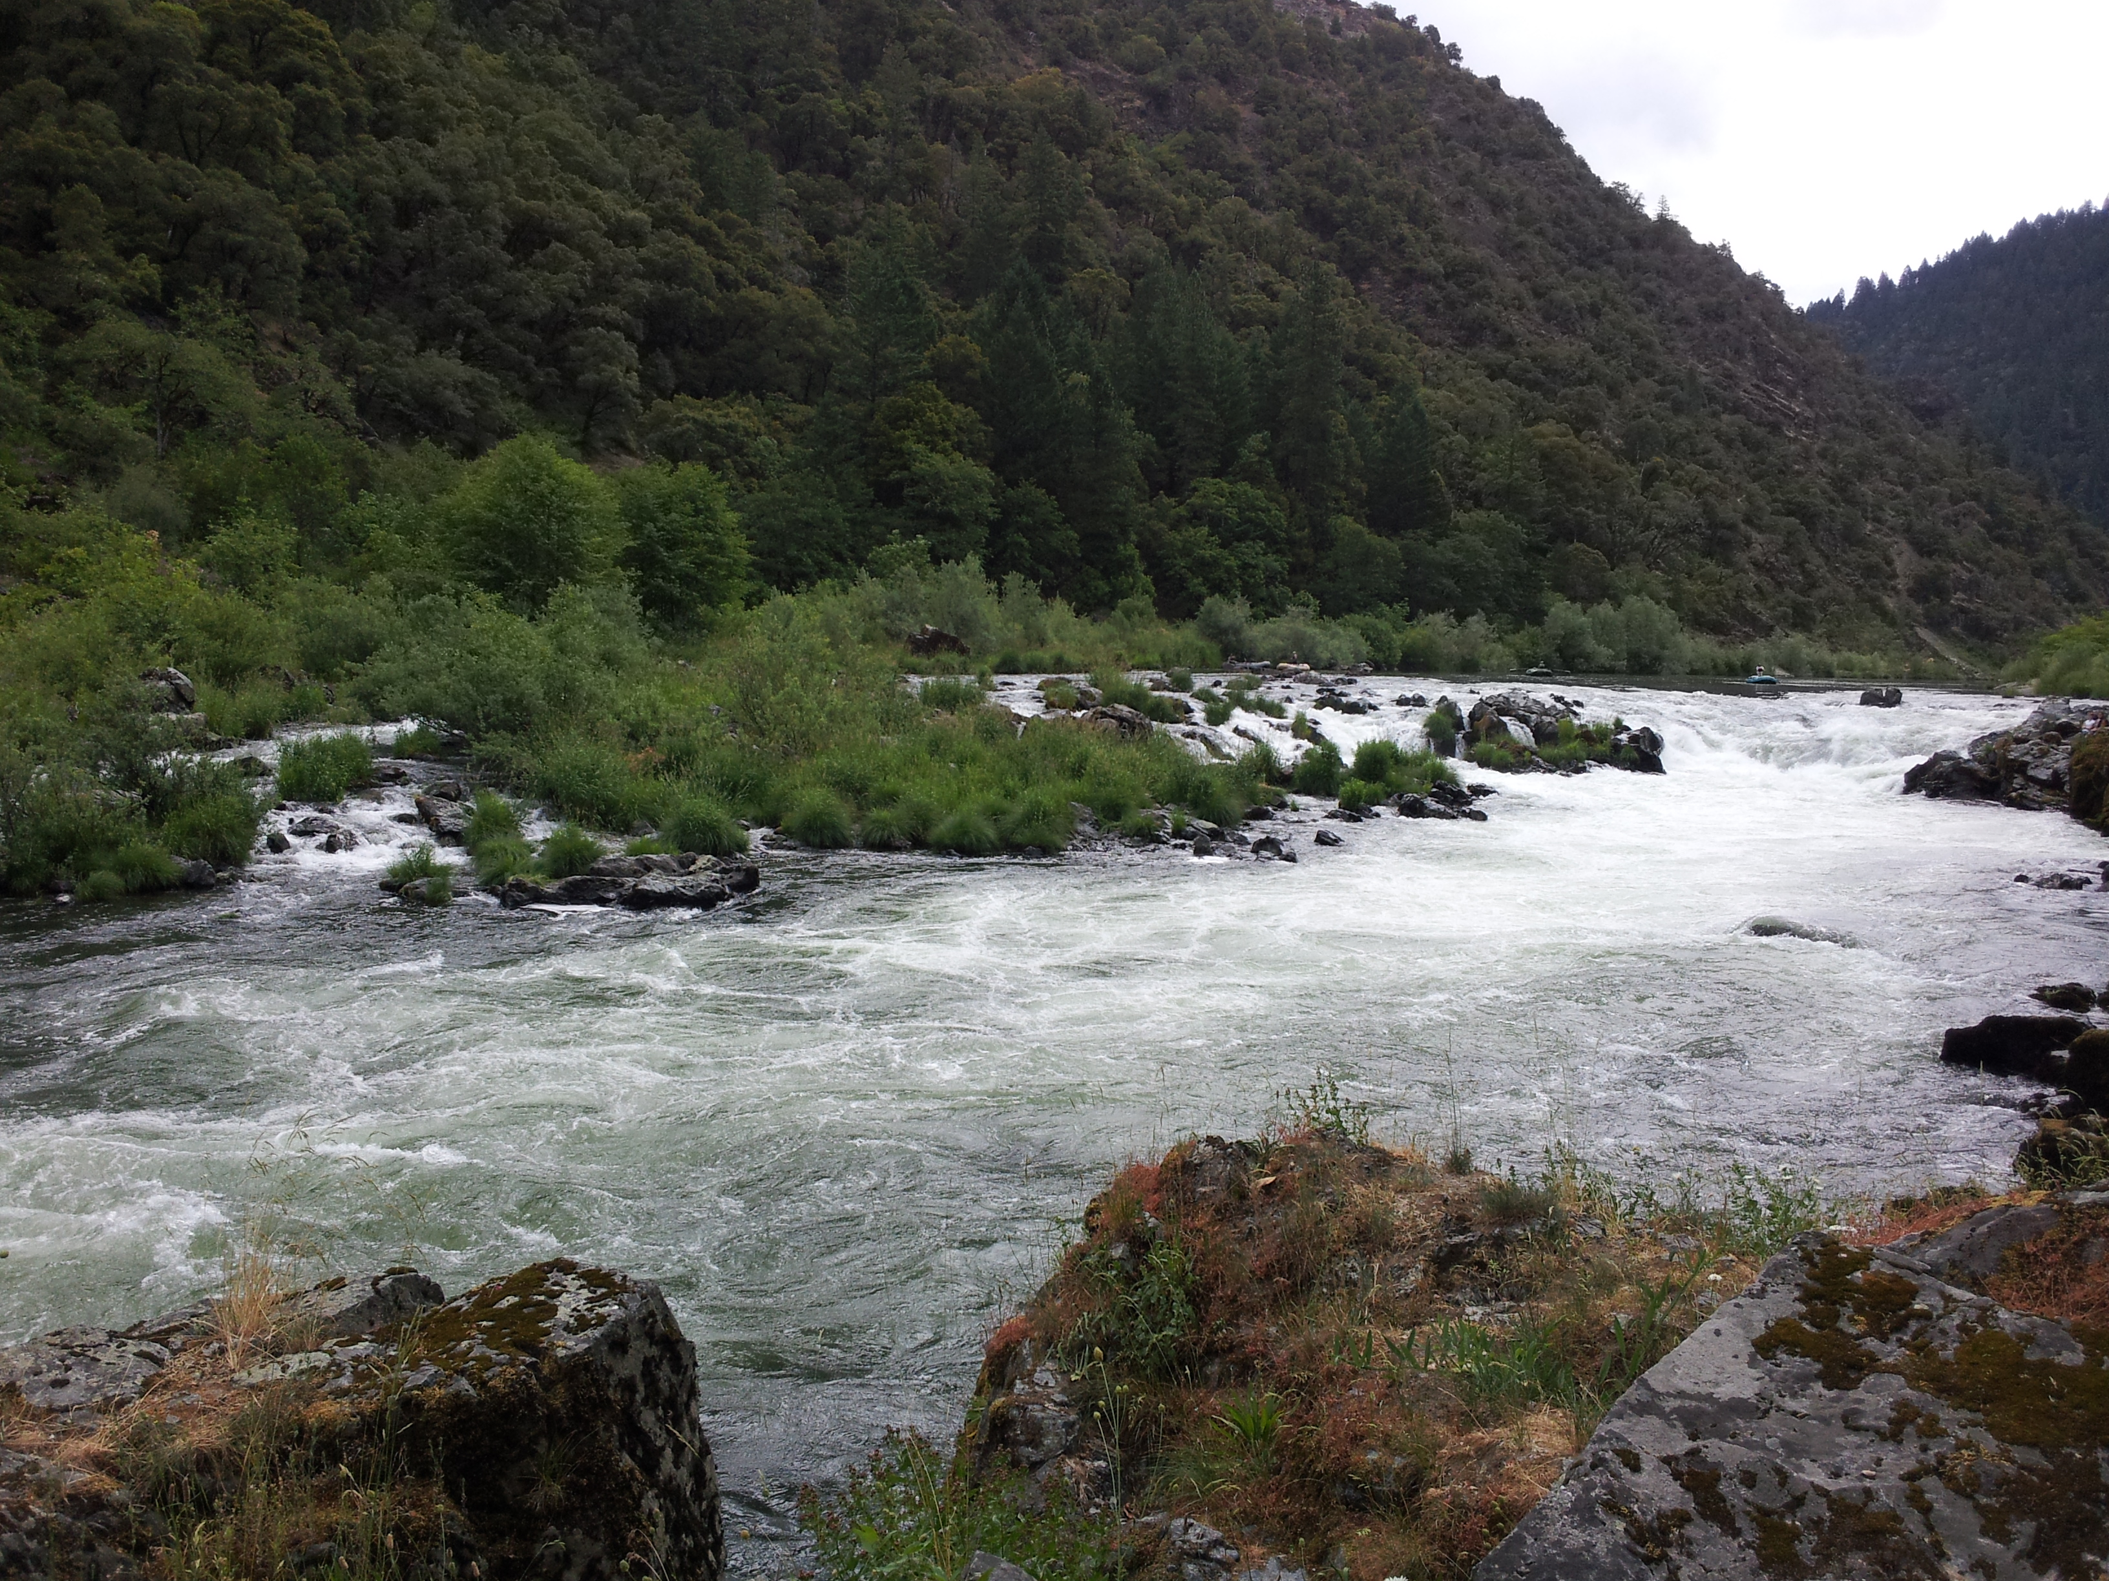

The Gold Beach and Powers Ranger Districts of the Rogue River-Siskiyou National Forest will soon be advertising to fill a Zoned GS-0462-7 Forestry Technician (Developed Recreation/Wild & Scenic Rivers/ Wilderness/Trails). This position is a permanent, full-time position and the duty station is Gold Beach, OR. The District may also fill this position on a temporary basis for up to 120 days. The purpose of this outreach notice is to inform prospective applicants of these opportunities. If you are interested in the 120-day detail and/or permanent position, please complete the attached outreach response form by December 26, 2014. For additional information about the position, please contact Lorelei Haukness (Recreation Program Manager) at 541-247-3640 or lhaukness@fs.fed.us.

Application Information
This position will be advertised on the USAjobs website (www.usajobs.gov).

Gold Beach and Powers Ranger Districts
Located in southwestern Oregon, the Gold Beach and Powers Ranger Districts offer amazing, year-round recreation, including five wild and scenic rivers, over 200 miles of hiking trails, five federally-designated wilderness areas, and a range of camping opportunities from the highly-developed campgrounds along the lower section of the Rogue River to dispersed campsites deep in the Kalmiopsis Wilderness.

Position Duties
Provides oversight for the developed recreation program, including operation and maintenance of facilities (e.g. campgrounds, recreation rentals, and boat launches); work leadership for one permanent, seasonal GS-0462-07 employee and two temporary GS-0462-04 employees; technical guidance and support needed to maintain complex water systems; coordination with contractors and volunteer campground hosts; hazard tree assessments and abatement; fee collections; and visitor compliance patrols.
Coordinates field work in support of a year-round wild and scenic river program. Emphasis will be placed on increasing Forest Service presence on the Rogue and Chetco Rivers, enhancing visitor services through the use of fees collected under the Federal Lands Recreation Enhancement Act, and monitoring visitor compliance with Forest Service regulations. Employee will coordinate with Bureau of Land Management staff at Rand Visitor Center to provide safe, high-quality recreation experiences on the Wild Section of the Rogue River. Employee will also coordinate with Forest Service resource specialists, including the Fire Management Officer, botanist, wildlife biologist, and archeologist, to provide support for projects occurring on wild and scenic rivers.
In addition, this employee will be responsible for partnership development and volunteer coordination for the zoned recreation program. Emphasis will be placed on the expansion of existing, and development of new, partnerships in support of the trails and wilderness stewardship programs.
This is a field-going position and southern Oregon can be a challenging place to work! Large portions of the District, including the Wild Section of the Rogue River and the Kalmiopsis Wilderness are only accessible by boat or foot. The selected employee will participate in the Oregon Marine State Board’s drift boat and jet boat operator training programs, and will be expected to work towards becoming a licensed boat operator.

Gold Beach Area Information
Located on the Wild Rivers Coast of southern Oregon, Gold Beach (pop. 1,900) is situated in Curry County (pop. 22,000) at the mouth of the Rogue River. The Rogue River provides some of the best salmon fishing and whitewater rafting opportunities in the Pacific Northwest. Other popular recreational activities include beach combing, biking, hiking, surfing, kite boarding, and windsurfing. The climate is generally mild, with summertime temperatures in the mid-60s. Winters are cool and wet, and snow is common in the mountains. Average annual rainfall is 80 inches. More information about the Gold Beach area may be found at http://goldbeach.org/ or http://oregon.hometownlocator.com/or/curry/gold-beach.cfm.

OUTREACH RESPONSE FORM

Zoned Forestry Technician

(Developed Recreation, Wild & Scenic Rivers, Trails, and Wilderness)

Detail / Permanent Position

GS-0462-7

If you are interested in this 120-day detail and/or permanent position, please complete this form and email it to lhaukness@fs.fed.us by December 26th, 2014. If you do not have access to electronic mail, please complete the form and mail or fax to: Lorelei Haukness, Gold Beach Ranger District, 29279 Ellensburg Ave., Gold Beach, OR or (541) 247-3617 (fax).
Name |  | Date
Address
City |  | State
Zip |  | E-Mail
Phone number(s):
Are you currently a federal employee? ___YES ___NO
If yes, current agency and location:
Current title/series/grade:
Type of appointment: ___ Permanent ___ Term ___ Temporary
Are you interested in the: ___ Permanent Position ___ Temporary Detail ___ Both
If you are not a current permanent (career or career conditional) employee, are you eligible for appointment under any of the following special authorities (check the appropriate box):
 | Person with Disabilities
 | Veteran Recruitment ACT
 | Former Peace Corps Volunteer
 | Disabled Veteran with 30% Compensable Disability
 | Pathways Student Program
 | Veterans Employment Opportunities Act 0f 1998
 | Other, please describe:

Briefly describe why you will be a quality candidate for this position (attach a page if needed):

Describe your experience supervising or directing the work of employees?

What is your skill level and experience related to whitewater boating. Please include any experience with rafting, use of a drift boat, or jet boat use.

What is your specific experience related to management of wild and scenic rivers, developed recreation, and trails?

