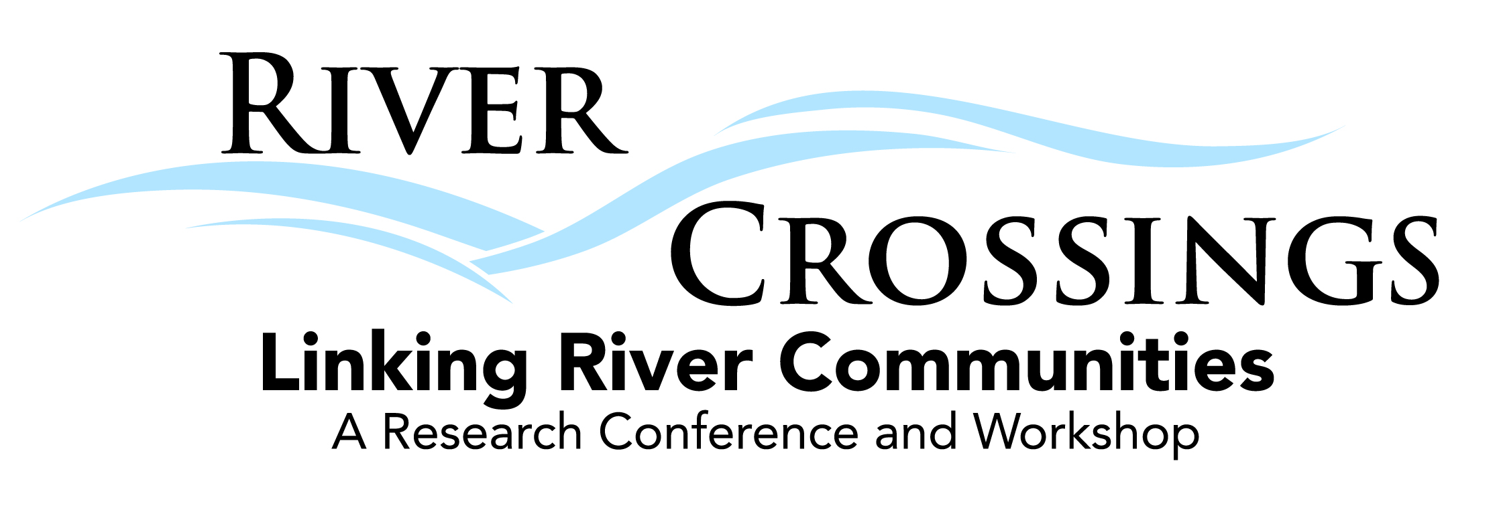

Where to Stay
River Crossings conference and workshop has partnered with three downtown Grand Junction hotels to provide lodging for attendees. A block of rooms has been reserved at each hotel at a reduced rate of $84.00 per night. We encourage attendees to reserve a room at their earliest convenience as the hotels will only hold these rooms and rates until February 11th, 2013. Please mention the booking codes when making your reservation.
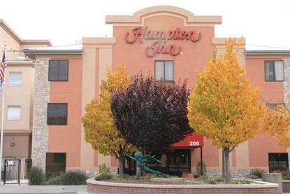
Hampton Inn
205 Main Street, Grand Junction, CO, 81501
Phone: 970-243-3222, Fax: 970-254-8208
www.grandjunction.hamptoninn.com
BOOKING CODE: rky – (One king or two queen beds)

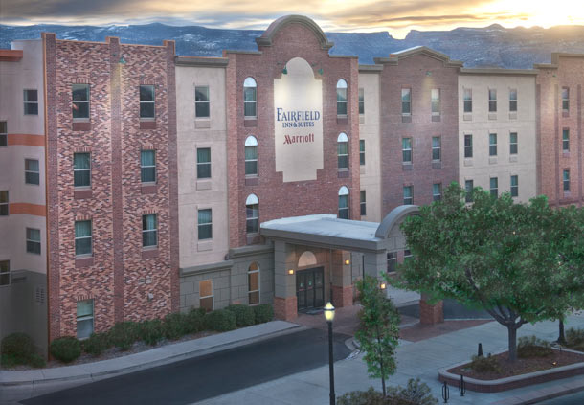

Fairfield Inn and Suites

225 Main Street, Grand Junction, CO, 81501
Phone: 970-242-2525, Fax: 970-242-0295
www.marriott.com/GJTFI
BOOKING CODES: tamtama- (One queen bed) OR tamtamb- (Two queen beds)

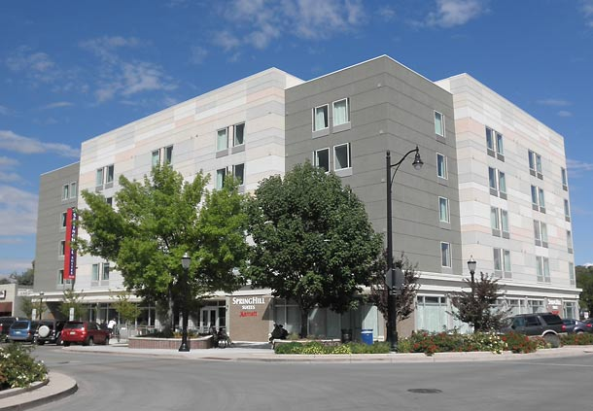

SpringHill Suites

236 Main Street, Grand Junction, CO, 81501
Phone: 970-424-5777, Fax: 970-424-5112
www.marriott.com/GJTSH
BOOKING CODES: tamtama- (One king bed) OR tamtamb- (Two queen beds)

Additional Hotel and Camping Accommodations
For more information on other places to stay in Grand Junction, please visit http://www.visitgrandjunction.com/accommodations/

Rental Cars
Alamo
2828 Walker Field Dr, Grand Junction, CO 81506
(970) 243-3097

Budget
2828 Walker Field Dr, Grand Junction, CO 81506
(970) 243-3851

Dollar
750 Horizon Dr, Grand Junction, CO 81506
(970) 255-9400

Enterprise Rent-A-Car
2828 Walker Field Dr, Grand Junction, CO 81506
(970) 254-1700

Hertz Rent-A-Car
2828 Walker Field Dr, Grand Junction, CO 81506
(970) 243-0747

Thrifty Car Rental
750 1/4 Horizon Drive, Grand Junction, CO 81506
(970) 243-7556

