Northwest/Pacific Chapters’ RMS Klamath River Trip
October 11-13, 2014
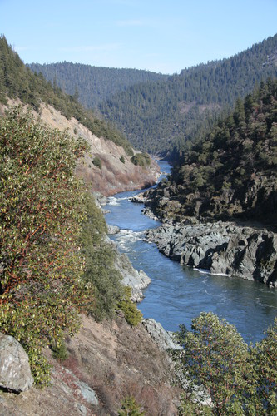
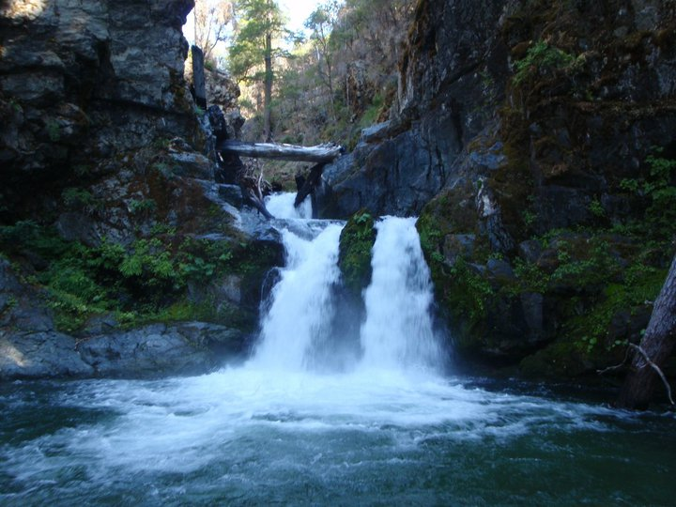
Adventure hike to Ukonom Falls (above)
Klamath River (left)
The Northwest and Pacific Chapters of the River Management Society (RMS), in partnership with the Klamath National Forest, Happy Camp Ranger District, is hosting an October river trip on the Klamath Wild and Scenic River in Northern California. The Klamath River is both the second longest and second largest river in the state of California. It was designated a Recreational River within the National Wild & Scenic Rivers System in 1981. The river makes its’ way through the Cascade and Coastal Mountain Ranges before it eventually flows into the Pacific Ocean. Fall colors will be shining along the banks in October, salmon will be swimming upstream, wildlife is abundant and you might even see Bigfoot!

The Klamath River trip will launch from the Indian Creek boat ramp and take-out at the Coon Creek boat ramp, for a total trip length of 20 river miles (2 days/1 night), with an OPTION** for a third day for those who want to see seven more river miles. The river is mostly Class III, with one class IV (Dragon’s Tooth) on the second day. It’s hard to predict the flow this year, could be around 900-1000 cfs or lower, unless there has been rain. Rafts, catarafts, river boards, IK’s and hardshell kayaks are the preferred watercraft for this float. Rafters should be comfortable with Class III rapids and be able to “follow the leader”. Kayakers should have Class III experience. If you don’t have the experience, it’s OK! There could be some open seats on experienced boater’s watercraft, as well as options to take out a Forest Service inflatable kayak. Contact us, and we will do our best to arrange an open seat for you!

**MONDAY you will have an option to boat a 7 mile section from Seattle Creek to Portuguese Creek. This section is just upstream from the town of Happy Camp. More fun on class II/III rapids as well as wildlife viewing opportunities and beautiful forested scenery. Monday will be on your own for food. We would love for you to join us and see more of the Klamath River!

Trip Logistics

Registration: The trip is first open to RMS members for $65, then non-members.
Non-members wishing to join the trip will be charged $115 ($65 plus $50 which includes a one year membership to RMS). Registration is first-come, first-served and is limited to 16 participants (including host staff). To register, mail the registration form and a check (made out to Dave Payne) for $65 ($115 non-members) to the following address:

Dave Payne
P.O. Box 1093
Happy Camp, CA 96039

The deadline for registration is 9/25/2014 or when the maximum group size of 16 people is met, whichever comes first. Please keep in mind that registration fees are non-refundable, be sure of your availability before registering. Visit the River Management Society website at www.rivermanagement.org to sign up as a member. Select the Professional membership for $50.

Pre-Trip Information: Participants should arrive in Happy Camp, CA Friday night by 6 pm and meet at the US Forest Service Ranger Station at 63822 Highway 96, Happy Camp, CA. Once everyone arrives, we will enjoy some of the best pizza you will ever have at the Pizza House! Camping is located about a mile away at the Curly Jack Campground and is included in the registration fee (along with Sunday night’s camping).

Floating Logistics: We will launch on Saturday morning (Oct 11) around 11 AM from the Indian Creek boat ramp and spend 2 days and 1 night on the river, coming off on Sunday afternoon (Oct 12) at the Coon Creek boat ramp. Due to the ongoing drought this season, the trip will be set up as a car camping support. Dragon’s Tooth, Class IV, is not ideal to float through with gear on the boat at low water levels. Packets with more detailed information will be provided to participants. Here is a link to see Google Earth of the river, rapids and access sites. http://www.fs.usda.gov/recarea/klamath/recarea/?recid=13066

Shuttles: Shuttles will be done ourselves. Vehicles with the necessary camping gear will be shuttled to the Ferry Point camping area along the river for Saturday evening, and then again on Sunday morning to the Coon Creek take out.

Hiking: The second day will include a ¾ of mile “Adventure” hike to Ukonom Falls. This hike will be on somewhat steep terrain and will have a few stream crossings, ending at a beautiful waterfall with a refreshing pool. You may choose to enjoy and relax on a beach along the river instead.

Meals: Meals from lunch on 10/11 through lunch on 10/12 will be provided. Breakfast on 10/11 and Dinner on 10/12 are on your own (The Pizza House, once again has AWESOME pizza!). If you continue on the river for seven more miles on Monday, all meals are on your own.

Weather & Gear: Rain could be possible in October and temperatures can range from
40-80 degrees. The past few years it has been on the warmer/sunnier side. But, please be prepared for a wide range of weather conditions. Confirmed participants will receive a recommended gear list with their trip packet.

Fishing: Bring your rod for the chance to catch Chinook Salmon, Steelhead and possibly Coho Salmon! Fishing licenses are sold at the Double J store in Happy Camp.

Directions:
To Happy Camp US Forest Service Ranger Office
63822 Highway 96
Happy Camp, CA 96039

From I-5 North:
Take exit 55 in Oregon off of the I-5 for the 199 S. Turn left onto Waldo Road, just a little ways after Cave Junction. Continue to go straight through the stop sign onto Greyback Road, which takes you up and over a pass. This will eventually turn into Indian Creek road and will bring you into the town of Happy Camp. (40 miles or so) Make a right onto Route 96 and the USFS station is on the left.

From I-5 South:
Take exit 786 in California off of the I-5 for 96 W, also called the Klamath River Highway. Follow this for about 65 miles to Happy Camp. The USFS Station will be on the left.

From 101 South (Arcata area):
Take exit 716A off the 101 for 299 E. Turn left onto 96 E. Follow 96 for about 82 miles and you will arrive in Happy Camp. USFS Station will be on your right.

From 101 North (Southern Oregon area):
Turn left onto 197 S off the 101. Turn left onto 199 N. Turn right onto Waldo Road (if you get to Cave Junction you have gone too far). Continue to go straight through the stop sign onto Greyback Road, which takes you up and over a pass. This will eventually turn into Indian Creek road and will bring you into the town of Happy Camp. (40 miles or so) Make a right onto Route 96 and the USFS station is on the left.

Post Trip Information: We should be off the river around 5pm on Sunday, October 12th, and if you opt for Monday, around 3 pm on October 13th. Additional travel information will be sent to participants. Camping at Curly Jack Campground Sunday evening is included in your registration fee.

For additional information on this trip, contact:

Lisa Byers or Dave Payne
(301) 514-3124 (530) 493-1762
Lmbyers4@gmail.com dapayne@fs.fed.us

